**CHAPTER 1**

**INTRODUCTION**

**SERVER:**

A server is a powerful computer that provides data, services, or resources to other computers, known as clients, over a network. Servers are essential components in various IT infrastructures, enabling functionalities like website hosting, email services, file sharing, and database management.

A **physical server** is a dedicated hardware device that provides computing resources such as processing power, memory, and storage to run applications and services. It is a single, standalone machine located in a data centre or on-premises.

A **virtual server** (also known as a virtual machine or VM) is a software-based representation of a physical server. Multiple virtual servers can run on a single physical server, sharing its resources.

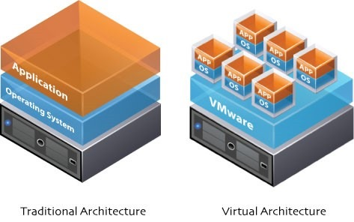

**Figure 1.1 Types of Servers**

**CLOUD:**

A cloud refers to servers that are accessed over the Internet, along with the software and databases that run on those servers. These servers are located in data centres all around the world. Instead of having physical servers and infrastructure in your home or office, you use the cloud to store data, run applications, and access computing resources.

**Uses of the Cloud:**

1. **Storage:-**
   * Save files and data: Store photos, documents, and videos online instead of on your local computer.
   * Backup: Automatically back up important files to prevent data loss in case your device is damaged or lost.
2. **Applications:-**
   * Web applications: Use applications like Google Docs, Microsoft Office 365, or online photo editors that run in the cloud and can be accessed from any device with an internet connection.
3. **Computing Power:-**
   * Virtual machines: Use virtual computers that run in the cloud for development, testing, and running applications.
4. **Streaming:-**
   * Media streaming: Watch movies, listen to music, and play games streamed from the cloud (like Netflix, Spotify, and Google Stadia).

**Everyday Examples:**

* Google Drive: Store and access your files from anywhere.
* Dropbox: Share files and collaborate with others.
* Netflix: Stream movies and TV shows online.
* Spotify: Listen to music from a vast online library.
* Amazon Web Services (AWS): Businesses use AWS to run websites, store data, and more.

The cloud makes it easier to store data, run applications, and access powerful computing resources without needing to own and manage physical infrastructure. It brings flexibility, scalability, and convenience to both individuals and businesses.

**CLOUD SERVICE PROVIDERS:**

A CSP (cloud service provider) is a third-party company that provides scalable computing resources that businesses can access on demand over a network, including cloud-based compute, storage, platform, and application services.

There are many cloud computing providers today, with some of the largest including:

* + Google Cloud Platform
  + Amazon Web Services (AWS)
  + Alibaba Cloud for the Chinese cloud market
  + Microsoft Azure

**CLOUD SERVICES:**

A cloud service is a service delivered over the Internet, providing on-demand access to computing resources, such as servers, storage, databases, networking, software, and applications. These services are managed by cloud service providers (CSPs) and allow users to leverage scalable and flexible resources without the need to invest in physical infrastructure.

Cloud services are broadly categorized into three main types:

1. Infrastructure as a Service (IaaS)
2. Platform as a Service (PaaS)
3. Software as a Service (SaaS)

**1. Infrastructure as a Service (IaaS)**

IaaS provides virtualized computing resources over the internet. It includes servers, storage, networks, and operating systems.

EC2 (Elastic Compute Cloud) : Virtual servers for running applications.

S3 (Simple Storage Service) : Scalable object storage.

EBS (Elastic Block Store) : Block storage volumes for use with EC2.

VPC (Virtual Private Cloud) : Isolated cloud resources for secure networking.

**2. Platform as a Service (PaaS)**

PaaS provides a platform allowing customers to develop, run, and manage applications without dealing with the underlying infrastructure.

Elastic Beanstalk : Deploy and scale web applications.

RDS (Relational Database Service) : Managed relational databases.

**3. Software as a Service (SaaS)**

SaaS delivers software applications over the Internet, on a subscription basis, without the need to install or maintain software.

WorkDocs : Document storage and collaboration.

WorkMail : Secure email and calendar service.

Amazon Web Services (AWS), Microsoft Azure, and Google Cloud Platform (GCP) are the big three cloud service providers today. Amazon Web Services (AWS) delivers over 200 cloud services across multiple industries and technology categories.

A website can be deployed on an EC2 instance through different AMIs, some AMIs through which we can deploy are:

Ubuntu

Windows

**UBUNTU:**

Ubuntu AMI (Amazon Machine Image) is a pre-configured virtual machine image for running Ubuntu on Amazon EC2 instances. Maintained by Canonical, it provides a secure and optimized environment tailored for AWS, offering easy access to a wide range of software packages through the APT package manager.

**key features of ubuntu AMI:**

* Regular Updates and Security Patches:
* Ubuntu AMIs are regularly updated with security patches and software updates to ensure that instances are secure and up-to-date.
* Wide Range of Software:
* Comes with access to a large repository of software packages through the Ubuntu package management system, making it easy to install and manage a wide range of applications.
* Support for Multiple Ubuntu Versions:
* Available in various versions, including Long-Term Support (LTS) releases, which provide extended support and stability for critical applications.
* Strong Community and Documentation:
* Backed by a robust community and extensive official documentation, providing support, tutorials, and best practices for using Ubuntu on AWS.
* Integration with AWS Services:
* Seamless integration with AWS services and tools, such as AWS CloudFormation, AWS Systems Manager, and AWS Marketplace, enhancing the ease of management and deployment.

**WINDOWS:**

A Windows AMI (Amazon Machine Image) is a pre-configured virtual machine image provided by AWS that runs the Microsoft Windows operating system. It allows users to launch and manage Windows-based instances on Amazon EC2.

**Key features of Windows AMI:**

* Pre-configured Windows Environment:
  + Includes a pre-installed Windows operating system, which can range from Windows Server versions to Windows Desktop editions.
  + Provides a ready-to-use environment for applications that require Windows-specific functionality.
* Integration with AWS Services:
  + Seamlessly integrates with AWS services such as Amazon RDS, Amazon S3, and AWS CloudWatch.
  + Supports AWS-specific features like EC2 Spot Instances, Elastic Load Balancing, and Auto Scaling.
* Security and Compliance:
  + Regularly updated with security patches from Microsoft to ensure a secure and compliant environment.
  + Supports Windows-specific security features, including Active Directory and Group Policies.
* Customizable and Scalable:
  + Allows for the creation of custom Windows AMIs with pre-installed applications and configurations.
  + Easily scalable, with options to scale up or down based on demand using EC2 instance types.
* Remote Management and Access:
  + Supports remote management and access via Remote Desktop Protocol (RDP).
  + Allows for administrative control and management of instances from any location with appropriate network access.

**CHAPTER 2**

**EXECUTIVE SUMMARY**

An Amazon EC2 instance is a virtual server that runs on the Elastic Compute Cloud (EC2) service provided by Amazon Web Services (AWS). It offers a scalable and flexible computing environment, allowing users to deploy and manage virtual servers in the cloud. These instances function similarly to physical servers but benefit from the cloud’s inherent scalability and management capabilities. They are used for a wide range of applications, including web hosting, application development, and data processing.

EC2 instances are highly scalable, meaning you can adjust capacity based on your needs. They support on-demand scaling, allowing you to quickly launch instances and adapt to changing requirements. Cost management is a significant advantage of EC2. Finally, users have a wide range of operating systems to choose from, including various versions of Linux, Windows Server, and custom Amazon Machine Images (AMIs).

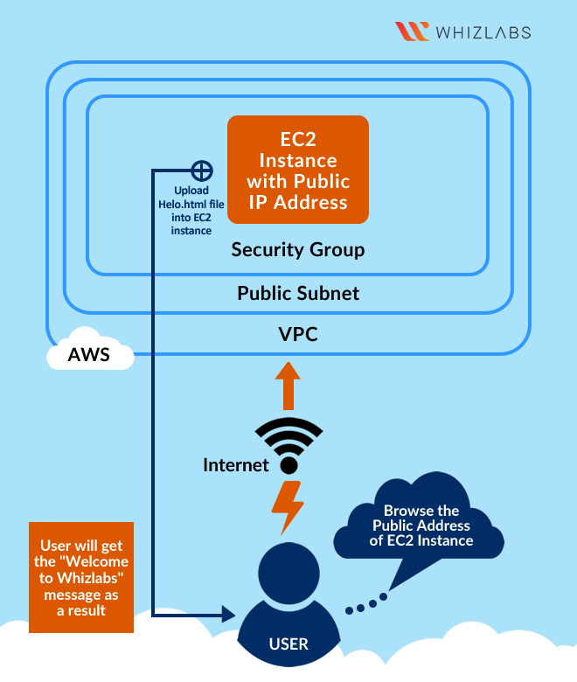

**Figure 2.1 Overview of deploying a website in VPC**

**Key components:**

* **Virtual Private Cloud (VPC):**

Amazon Virtual Private Cloud (VPC) is a service offered by AWS that allows users to create a logically isolated network within the cloud. It provides full control over the virtual networking environment, including IP address ranges, subnets, route tables, and network gateways. With VPC, you can isolate your network resources from other AWS customers and manage how resources within your VPC communicate with each other and with the outside world. This service offers customizable network configurations, allowing you to set up the network according to your specific requirements. VPCs also provide robust security features such as Security Groups and Network Access Control Lists (ACLs), which control inbound and outbound traffic, ensuring that your network remains secure.

* **Subnets:**

Subnetting is a key concept in managing VPC networks. It involves dividing a larger network into smaller, more manageable segments known as subnets. This division allows you to efficiently organize and allocate IP address space within your VPC. Each subnet can be associated with a route table that controls traffic flow between subnets and to and from the internet. Subnets can be classified into public and private categories: public subnets have routes to the internet through an Internet Gateway and are used for resources that require internet access, such as web servers, while private subnets do not have direct internet access and are typically used for internal resources like databases and application servers.

* **Launching Instance in subnets:**

By using subnetting within a VPC, you can achieve effective network segmentation, enhanced security, and better management of IP address allocations. Subnets are also associated with specific Availability Zones (AZs), contributing to fault tolerance and high availability by distributing resources across multiple AZs. Overall, VPC and subnetting together offer a powerful framework for designing, securing, and managing a scalable and flexible network infrastructure in AWS.

* **Deploying the website:**

To deploy a website on an Amazon EC2 instance, launch an EC2 instance via the AWS Management Console, connect to it using SSH or RDP, and install web server software like Apache or Nginx. Upload your website files to the server, configure the web server, and ensure DNS records point to your instance's IP address. Verify the website's accessibility, and set up security groups and monitoring tools to manage access and performance.

* **Use cases:**

|  |  |
| --- | --- |
| Scalability | Easily adjust resources to handle varying levels of traffic. |
| Flexibility | Customize the server environment to meet specific needs and requirements. |
| Cost Efficiency | Pay only for the resources you use, with options for cost-saving pricing models. |
| Control | Full control over server configurations and software installations. |
| Reliability | Benefit from AWS's robust infrastructure and high availability. |
| Security | Implement strong security measures with security groups and network access control. |
| Integration | Seamlessly integrate with other AWS services for a comprehensive solution. |
| Backup and Recovery | Helps quickly restore websites from backups if something goes wrong. |

**CHAPTER 3**

**ABOUT THE COMPANY**

In response to the rapidly evolving demands of the global job market, T-Hub has emerged as a pivotal platform dedicated to transforming engineering education and practice. The growing gap between traditional engineering education and industry requirements has highlighted the need for a transformative approach to preparing students for real-world challenges.

The impact of T-Hub on students is profound and transformative. By offering training that bridges the gap between theoretical knowledge and practical application, T-Hub helps students develop a competitive edge in the job market. The emphasis on real-world experience, problem-solving, and interdisciplinary communication prepares students to excel in diverse professional settings.

**Mission and Vision:**

T-Hub’s mission is to bridge the divide between academic learning and industry expectations by offering cutting-edge training programs that go beyond conventional technological education. The vision of T-Hub is to create a future-ready workforce capable of thriving in dynamic and interdisciplinary environments. By focusing on holistic development, including technical skills, problem-solving capabilities, and effective communication, T-Hub aims to foster a new generation of professionals who are well-prepared to tackle complex challenges and lead innovative projects.

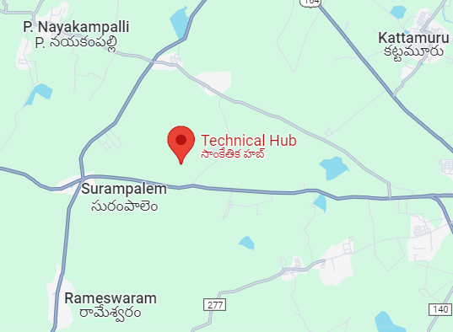

**Figure 3.1 Location of Company**

Website : https://technicalhub.io/

Industry : Industry Training and certification services

Company Size : 100 – 150 employees

Type : Incubator of Aditya Educational Institution

Founded : 2016

Specialties : Global certifications, placement training, Technology training

**CHAPTER 4**

**OPPORTUNITIES**

During these 7 weeks of the internship, I had the opportunity to undertake the following responsibilities

**Intern:**

* Coordinated with fellow interns who were also working on deploying websites on AWS cloud. We shared our knowledge and collaboratively solved challenges, enhancing our project outcomes through knowledge sharing.
* Learned about cloud computing, specifically focusing on AWS services and deploying websites on EC2 instances and Elastic bean stalk.
* Referred to online resources such as AWS documentation, AWS academy and various GitHub repositories to gain comprehensive knowledge about AWS EC2, AWS S3, EBS (Elastic Bean Stalk) and related services.
* Gathered the necessary requirements for deploying a website on AWS EC2, including setting up the instance, configuring security groups.
* Volunteered to participate in other projects, gaining exposure to various aspects of cloud deployment and integration.
* Gained hands-on experience with AWS Elastic Beanstalk, automating the deployment, scaling, and management of applications in the cloud.
* Managed S3 buckets for storage needs, including setting up versioning to maintain and retrieve previous versions of objects for data protection and recovery.
* Completed different tasks to develop and deploy websites on AWS EC2, including configuring the web server, uploading website files, and ensuring security measures.
* Underwent tests to certify the completion of the internship, which included successfully deploying our projects without errors and with optimal functionalities.

**CHAPTER 5**

**TRAINING**

In these 7 weeks of training, we were provided with comprehensive training on AWS EC2 and cloud technologies using practical, hands-on sessions. The training covered several key areas, including:

* Basic Linux Commands
* EC2 Instances
* Subnetting and IP Address Classes
* Elastic Beanstalk
* S3 Buckets and Versioning
* Security Groups
* Networking
* **Basic Linux Commands:**

We began with an introduction to essential Linux commands required for navigating and managing our EC2 instances. This included file management commands like **ls**, **cp**, and **mv** for listing, copying, and moving files. Network configuration commands such as **ifconfig** and **netstat** were also covered, providing us with the tools to manage network settings and monitor network connections.

* **EC2 Instances**:

We learned about creating and managing EC2 instances, which are virtual servers in the AWS cloud. This involved selecting appropriate instance types based on performance requirements, configuring security settings. We explored how to use key pairs for secure SSH access, set up Elastic IP addresses for consistent access, and use Amazon Machine Images (AMIs) for quick deployment of pre-configured instances. Additionally, we practiced using the AWS Management Console, MobaXterm, Putty, and AWS CLI to efficiently manage our EC2 resources.

* **Subnetting and IP Address Classes**:

We delved into the concept of subnetting, which involves dividing a network into smaller sub-networks to enhance performance and security. We learned how to calculate subnet masks and range accordingly. The training also covered different classes of IP addresses—Class A, B, C, D, and E—and their specific uses in network design and management. Understanding these concepts helped us design efficient and scalable network architectures within a VPC (Virtual Private Cloud).

* **Elastic Beanstalk**:

We received training on AWS Elastic Beanstalk, a service for deploying and scaling web applications and services. This involved deploying applications using pre-configured environments, managing application versions, and configuring environment settings for optimal performance. We learned how Elastic Beanstalk automates the provisioning of resources such as EC2 instances and databases. Additionally, we explored monitoring and logging features within Elastic Beanstalk to track application performance and troubleshoot issues.

* **S3 Buckets and Versioning**:

Training included managing S3 buckets for scalable storage solutions. We learned how to create and configure S3 buckets, set permissions using bucket policies. The training emphasized the importance of versioning in S3, which allows us to maintain and retrieve previous versions of objects, providing data protection and recovery options. We also explored using S3 for hosting static websites and integrating with other AWS services for enhanced functionality.

* **Security Groups**:

We explored configuring security groups, which act as virtual firewalls for controlling inbound and outbound traffic to our EC2 instances. The training covered creating and managing security group rules to allow specific types of traffic, such as HTTP, HTTPS, and SSH. Additionally, we practiced monitoring and adjusting security group rules to ensure the security of our applications and data.

* **Networking**:

The training covered VPC (Virtual Private Cloud) and subnetting, providing us with the skills to set up isolated networks within the AWS cloud. We learned how to create and configure VPCs, subnets, route tables, and internet gateways. Understanding these networking concepts helped us design and manage robust, secure, and scalable network infrastructures.

This training provided a solid foundation in deploying, managing, and scaling applications using AWS EC2 and other cloud services, equipping us with the skills needed for effective cloud infrastructure management.

**CHAPTER 6**

**DEPLOYING AN ECOMMERCE WEBSITE ON UBUNTU**

Deploying applications on Ubuntu, a popular and versatile Linux distribution, is a common practice due to its stability, security, and extensive community support. The process generally begins with selecting a suitable hosting environment, whether it's a virtual private server (VPS), cloud service, or dedicated server. Deploying an E-Commerce website on an Ubuntu server involves several steps to ensure a secure and efficient setup. This streamlined approach ensures a robust and scalable E-Commerce website deployment on Ubuntu, leveraging the reliability and flexibility of AWS EC2.

**Steps Involved:**

1. Login to AWS MANAGEMENT CONSOLE and go VPC dashboard.

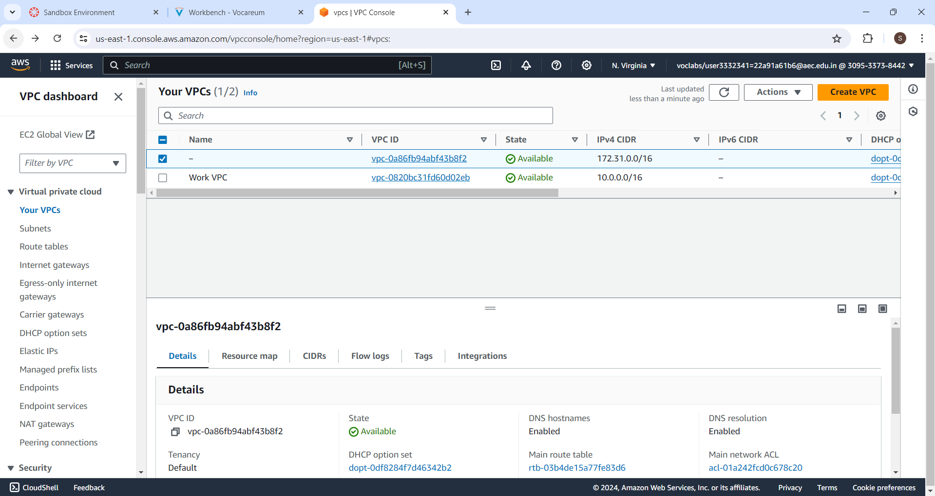

**Figure 6.1 VPC dashboard**

2.Create VPC

* Go to the VPC Dashboard.
* Click on "Create VPC".
* Specify a name for your VPC and an IPv4 CIDR block (e.g., 10.0.0.0/16).
* Click "Create VPC".

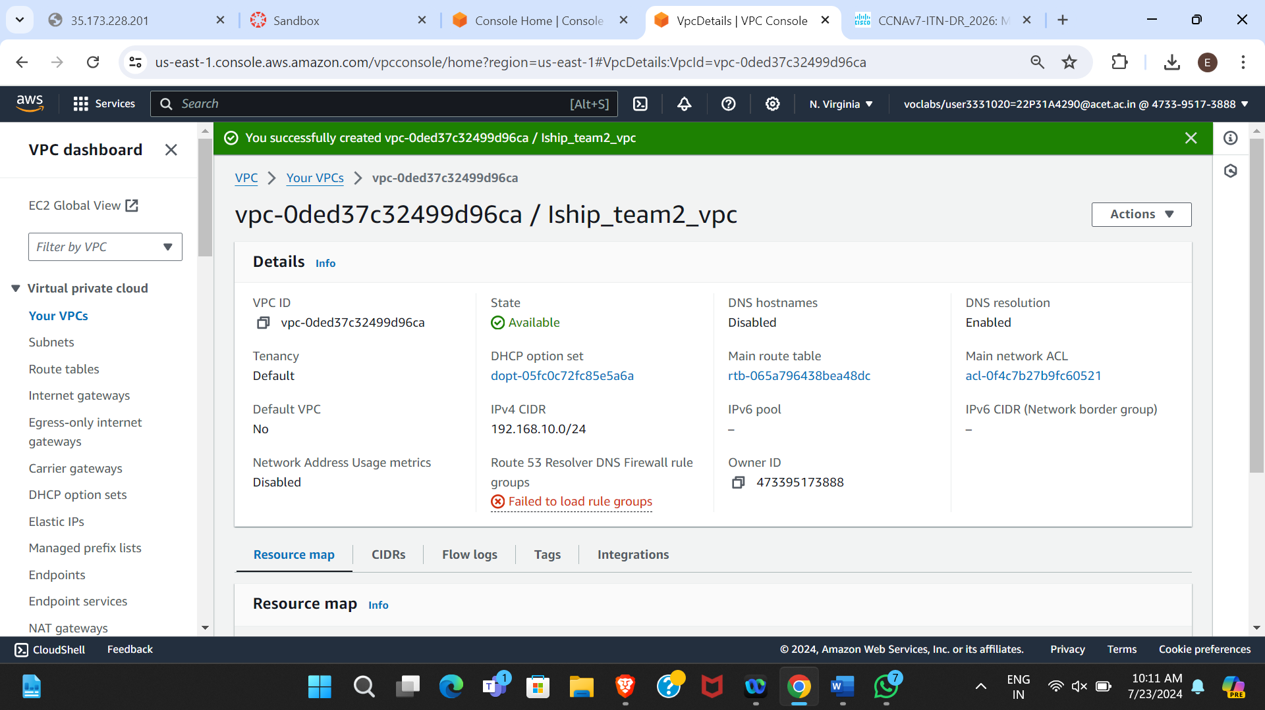

**Figure 6.2 VPC successfully created**

3.Create a SUBNET from which you can launch the instance.

* **Subnet**: A range of IP addresses in your VPC. You can launch AWS resources into a specified subnet.
* In the VPC Dashboard, click on "Subnets" and then "Create Subnet".
* Choose the VPC you created (Iship_team2_vpc).
* Specify a name for the subnet (Ubuntu).
* Select an Availability Zone and specify a CIDR block (192.168.10.0/26).
* Click "Create Subnet".

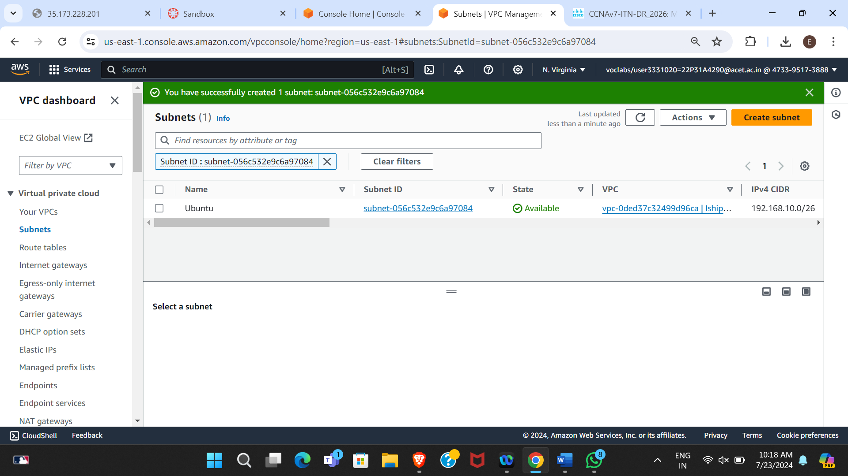

**Figure 6.3 Subnet successfully created**

4.Create an INTERNET GATEWAY.

* **Internet Gateway**: A horizontally scaled, redundant, and highly available VPC component that allows communication between your VPC and the internet.
* In the VPC Dashboard, click on "Internet Gateways" and then "Create Internet Gateway".
* Name the Internet Gateway and click "Create".

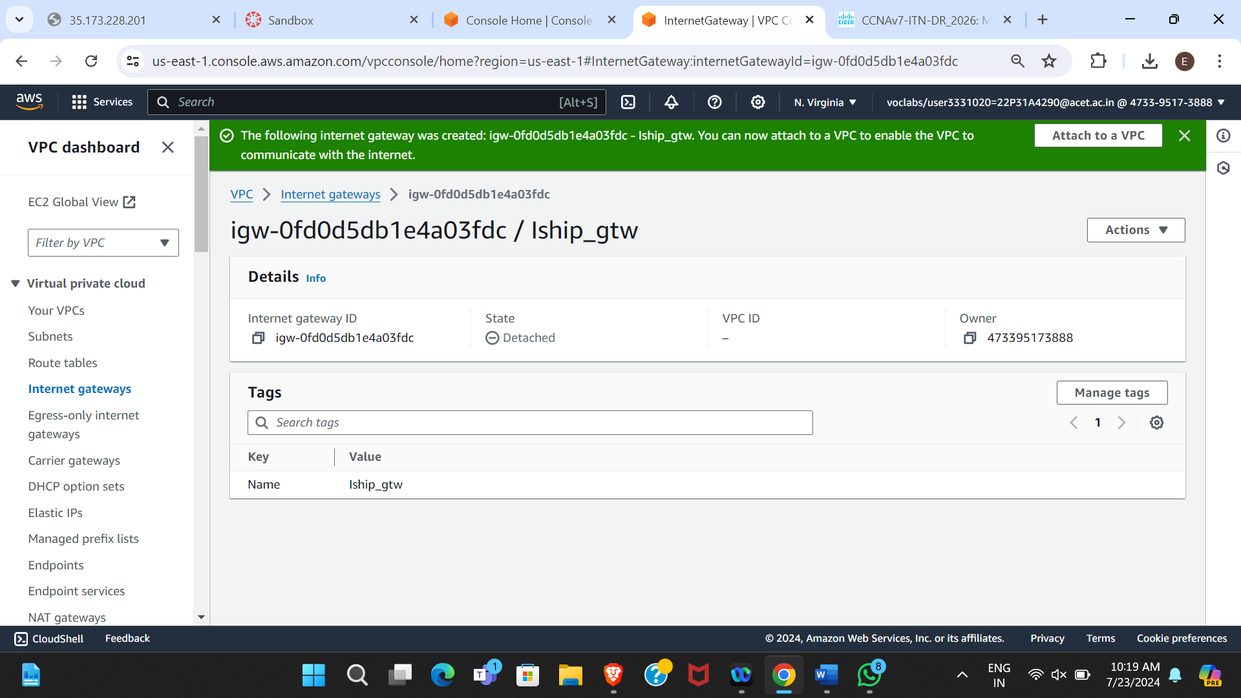

**Figure 6.4 Internet Gateway successfully created**

5.Attach the GATEWAY to VPC.

* Select the created Internet Gateway.
* Click on "Actions" and then "Attach to VPC".
* Select your VPC (e.g., Iship_team2_vpc) and click "Attach Internet Gateway".

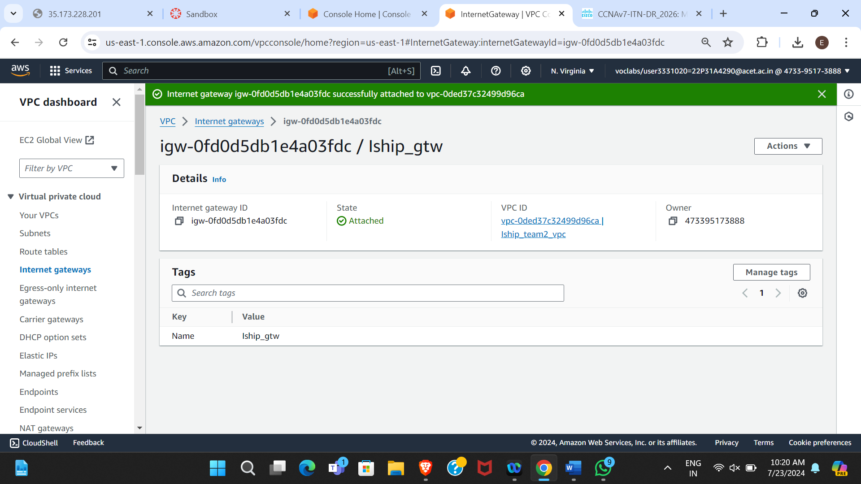

**Figure 6.5 Internet Gateway successfully attached to VPC**

6.Create a ROUTE TABLE, edit the “Subnet Associations” and add “Routes(Internet Gateway)”.

* **Route Table**: A set of rules, called routes, that are used to determine where network traffic is directed.
* **Subnet Associations**: Associating subnets with route tables.
* **Routes**: Entries in the route table that direct traffic to specific destinations.
* In the VPC Dashboard, click on "Route Tables" and then "Create Route Table".
* Name the Route Table, select the VPC (Iship_team2_vpc), and click "Create Route Table".
* Once created, go to "Subnet Associations" and associate the previously created subnet ( Ubuntu).
* Go to "Routes" and add a route:
  + Destination: 0.0.0.0/0
  + Target: Internet Gateway (Internet Gateway ID)

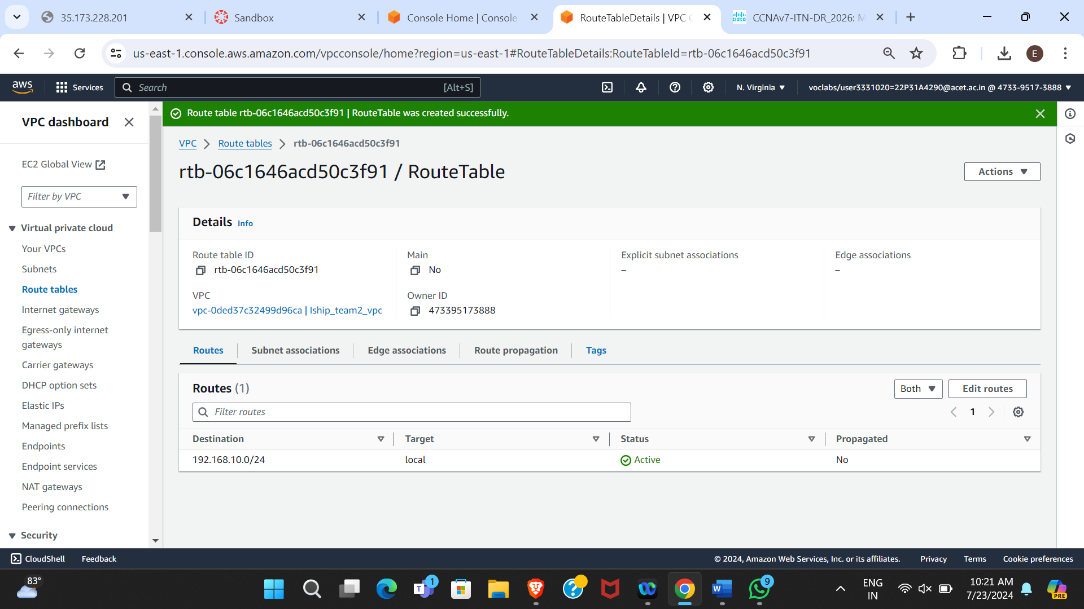

**Figure 6.6 Route Table created successfully**

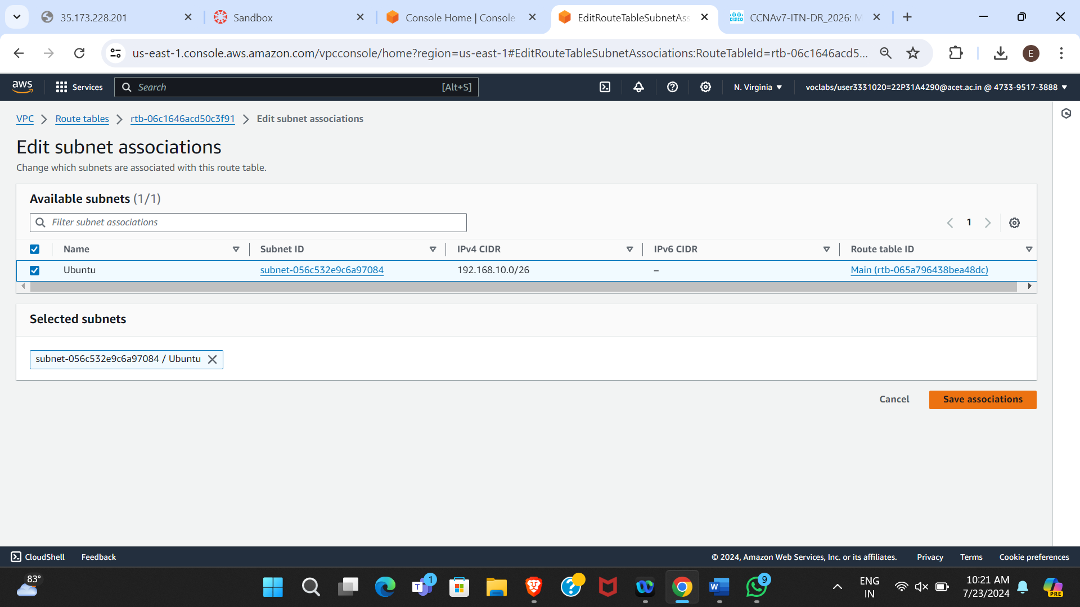

**Figure 6.7 Association of subnets to Route Table6**

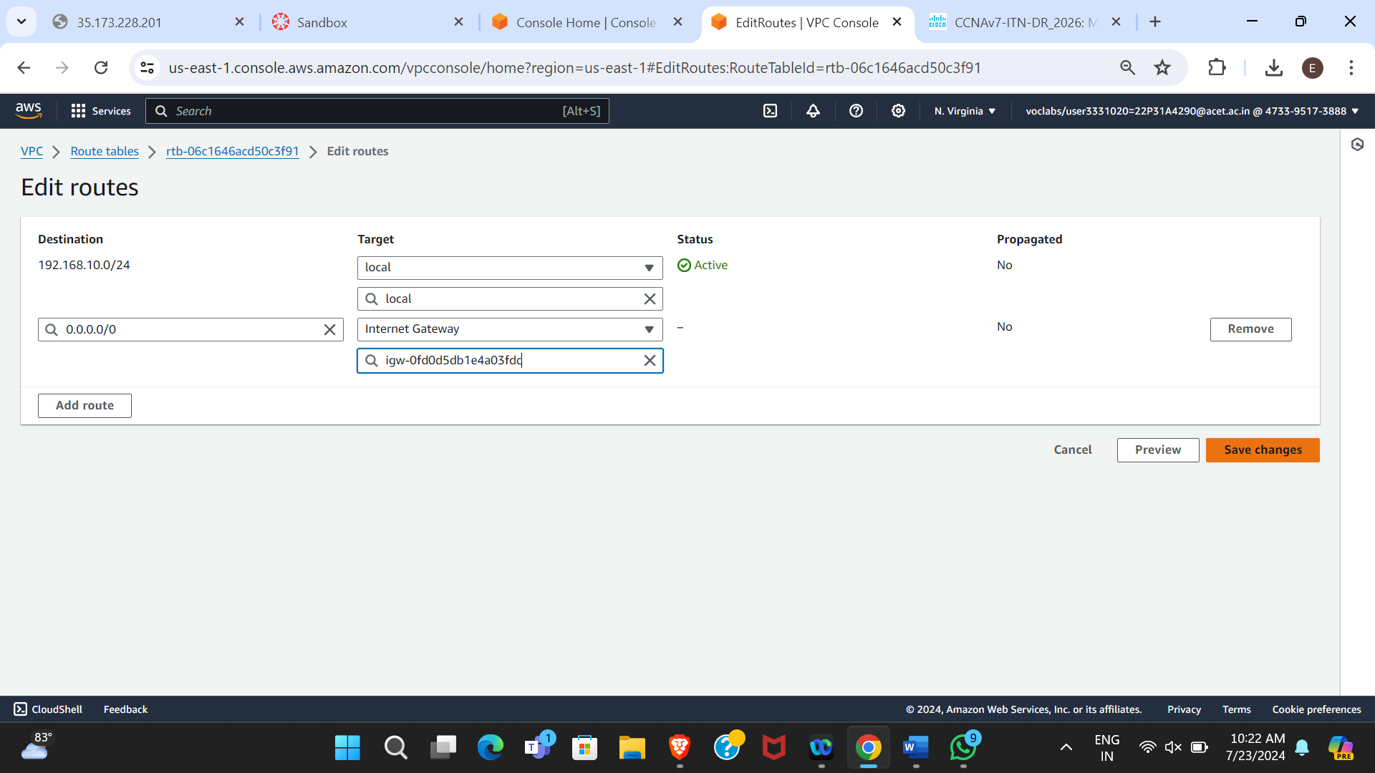

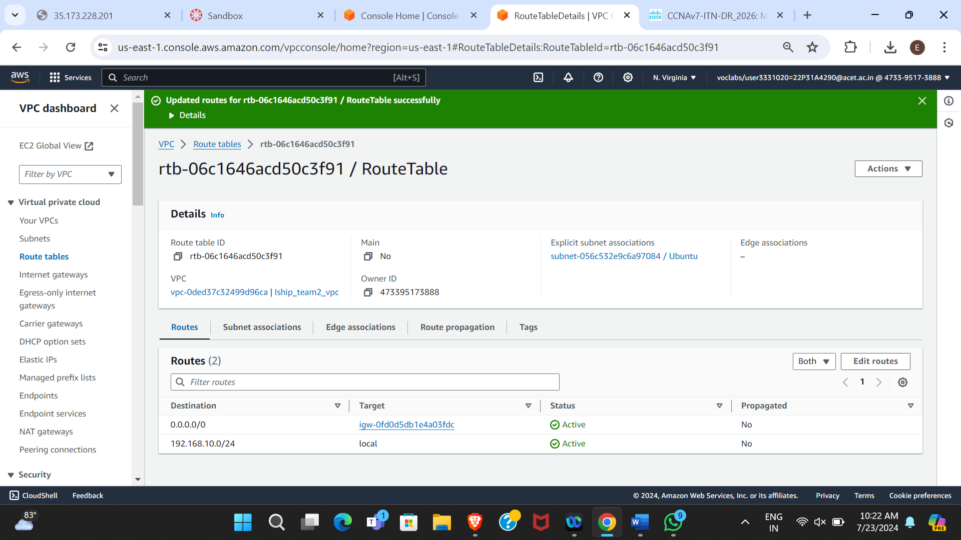

**Figure 6.8 Updating Routes in subnet**

7.Launch a EC2 instance with “UBUNTU AMI”.

* **EC2:**A webservice that provide resizable compute capacity in the cloud.
* **AMI (Amazon Machine Image)**: A template that contains the software configuration (operating system, application server, and applications) required to launch an instance.
* Go to the EC2 Dashboard and click “Launch Instance”.
* Choose an Ubuntu Server AMI (Ubuntu 22.04 LTS), select the instance type (t2 micro).
* Download the key pair to securely connect to your instance.
* Edit the network settings:
  + Select the VPC (Iship_team2_vpc) and subnet (Ubuntu).
  + Enable auto-assigned public IP.
* Configure instance details, add storage, and configure security groups (allow HTTP, HTTPS, and SSH), Review and launch the instance.

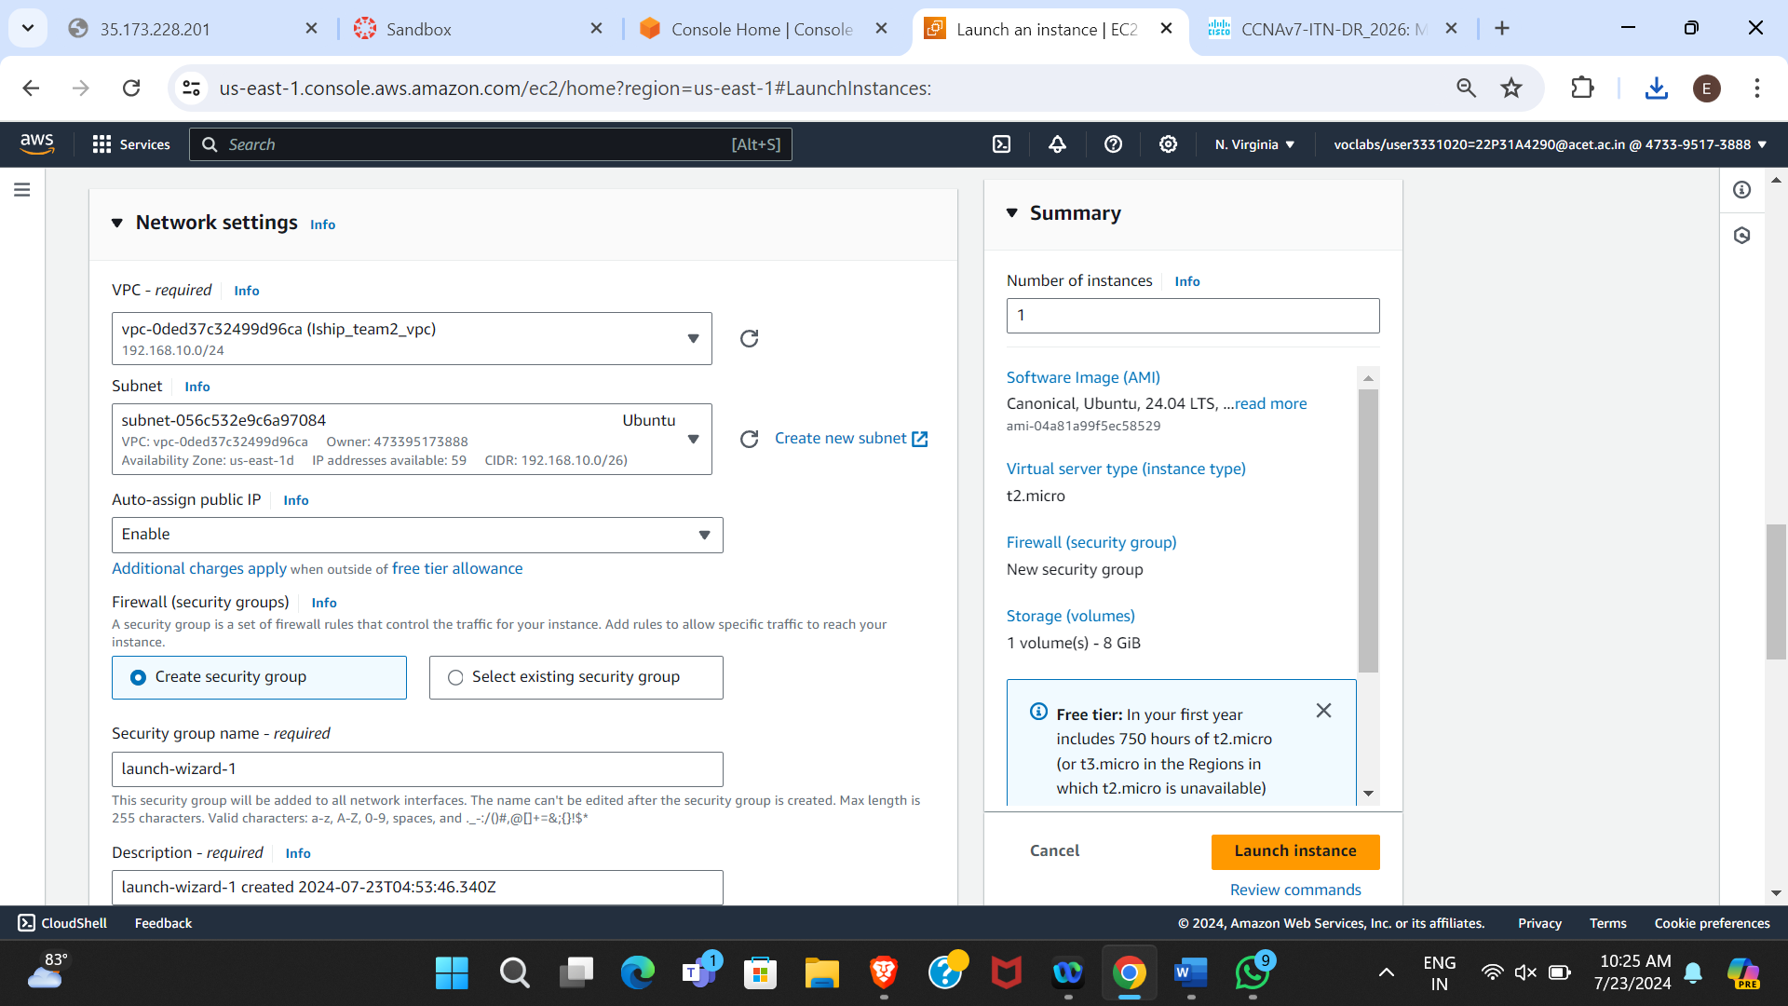

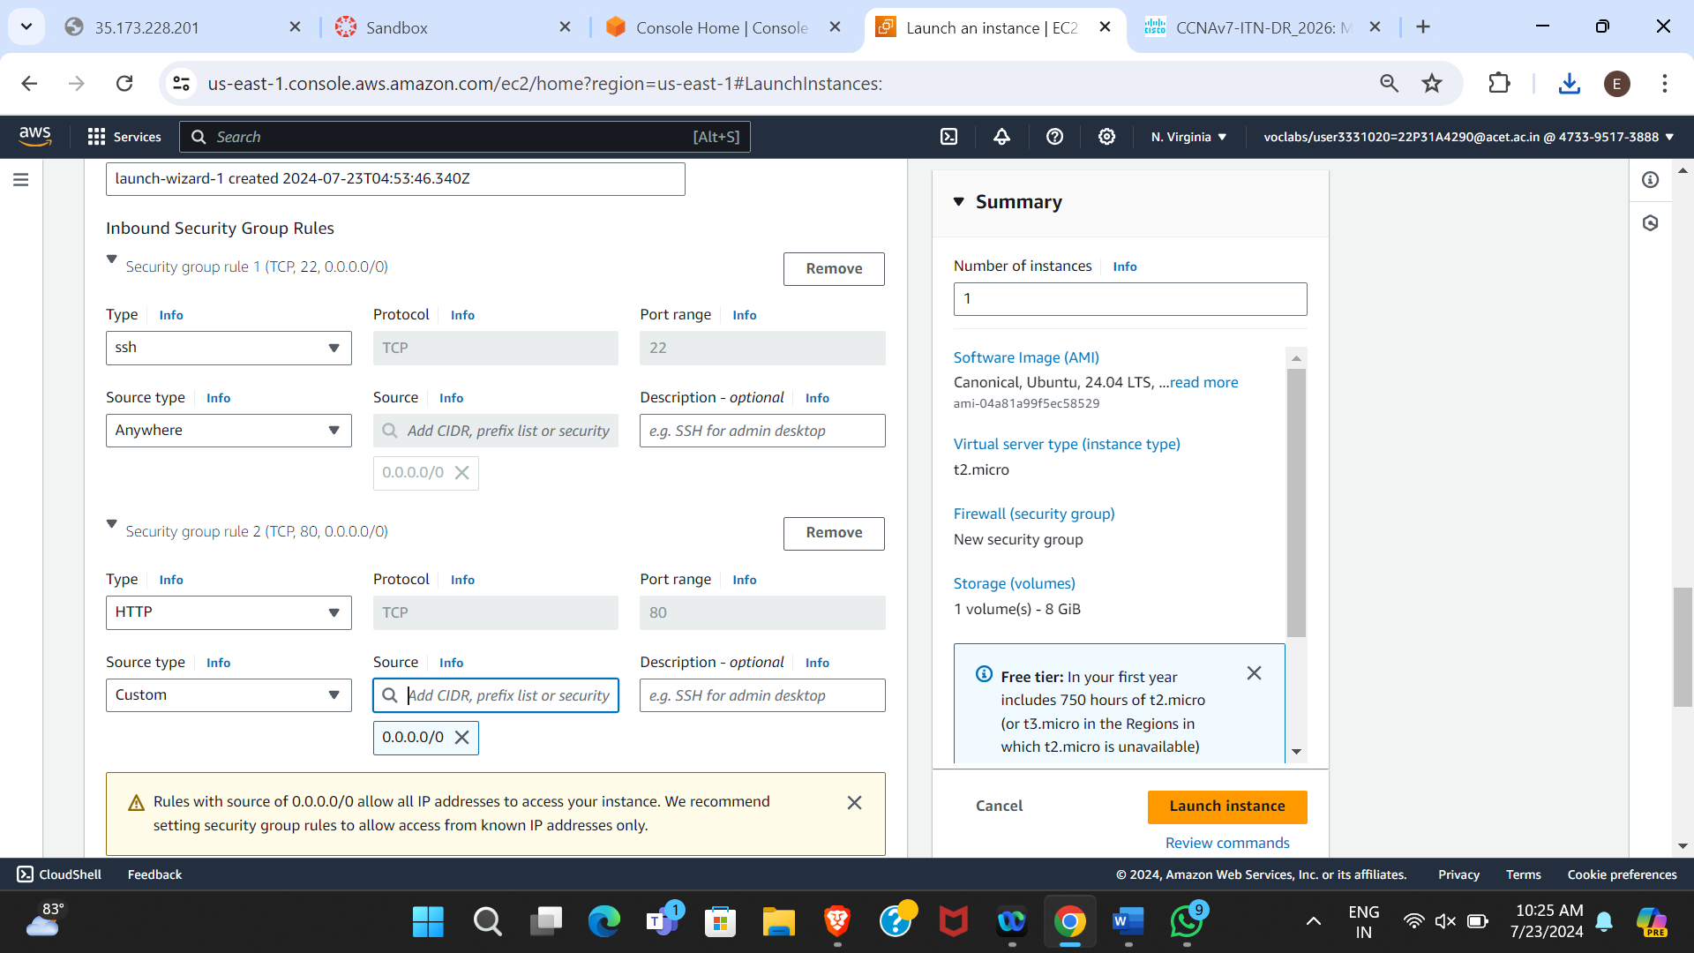

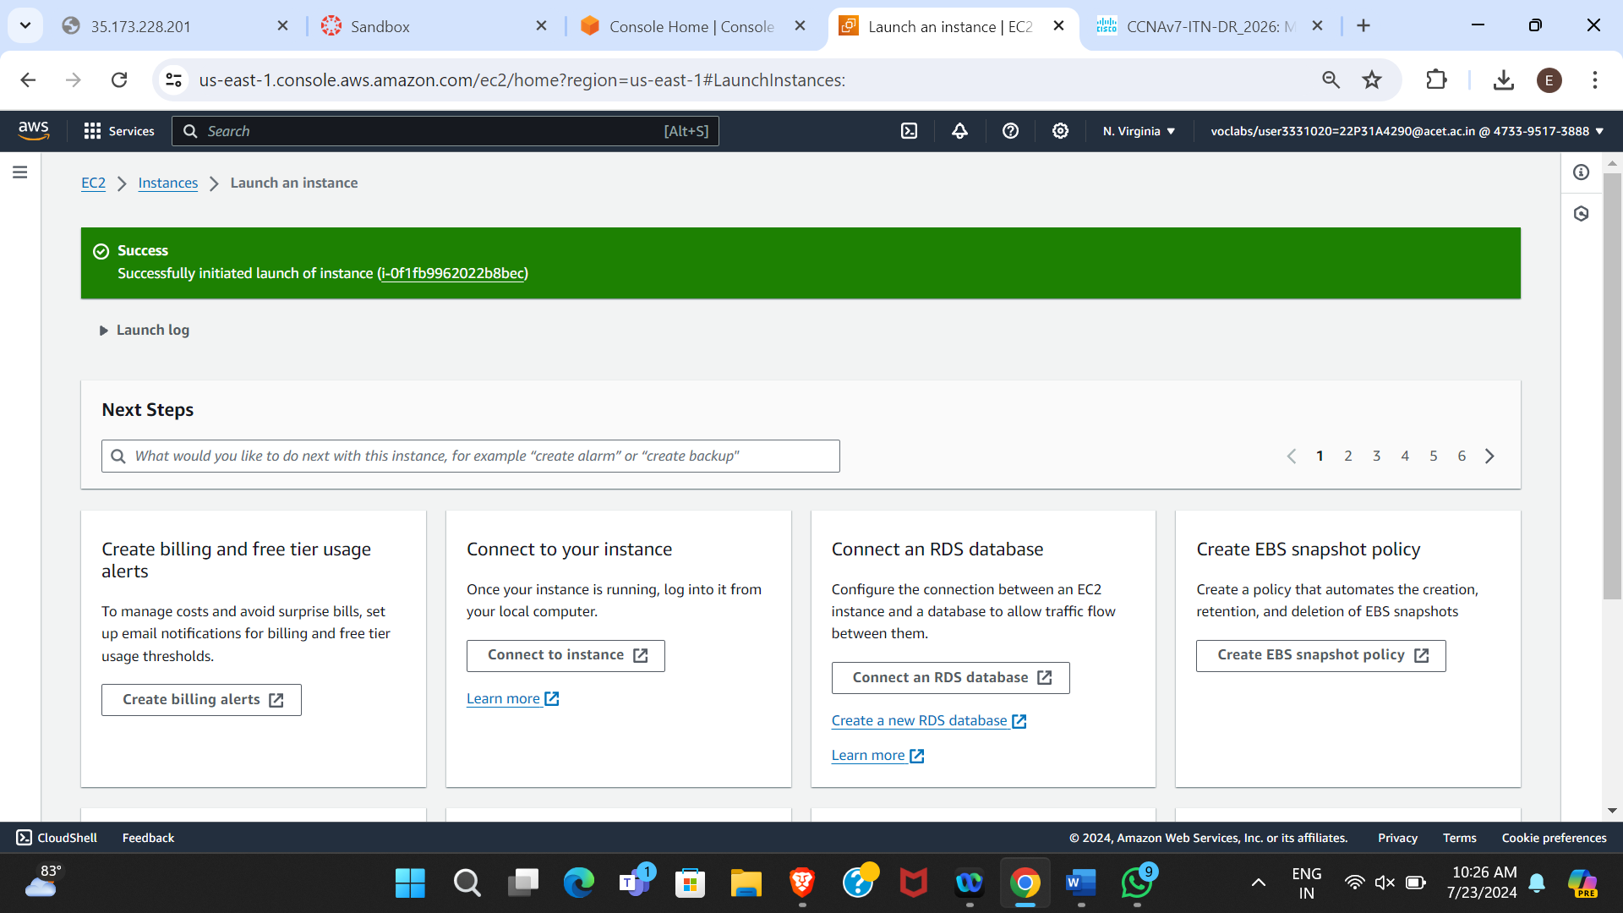

**Figure 6.9 Instance launched successfully**

8.Create an “Elastic IP address” and allocate it to the created instance.

* **Elastic IP Address**: A static IPv4 address designed for dynamic cloud computing.
* Go to the "Elastic IPs" section under the EC2 Dashboard.
* Click “Allocate Elastic IP address”.
* Once allocated, select the Elastic IP, click "Actions" and then "Associate Elastic IP address".
* Choose your instance and associate it.

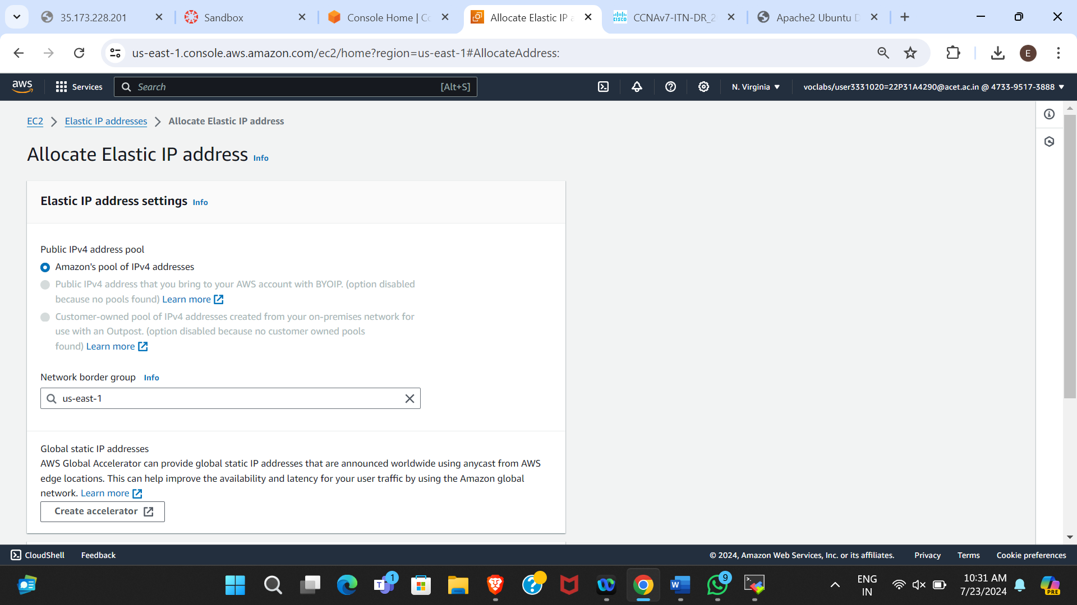

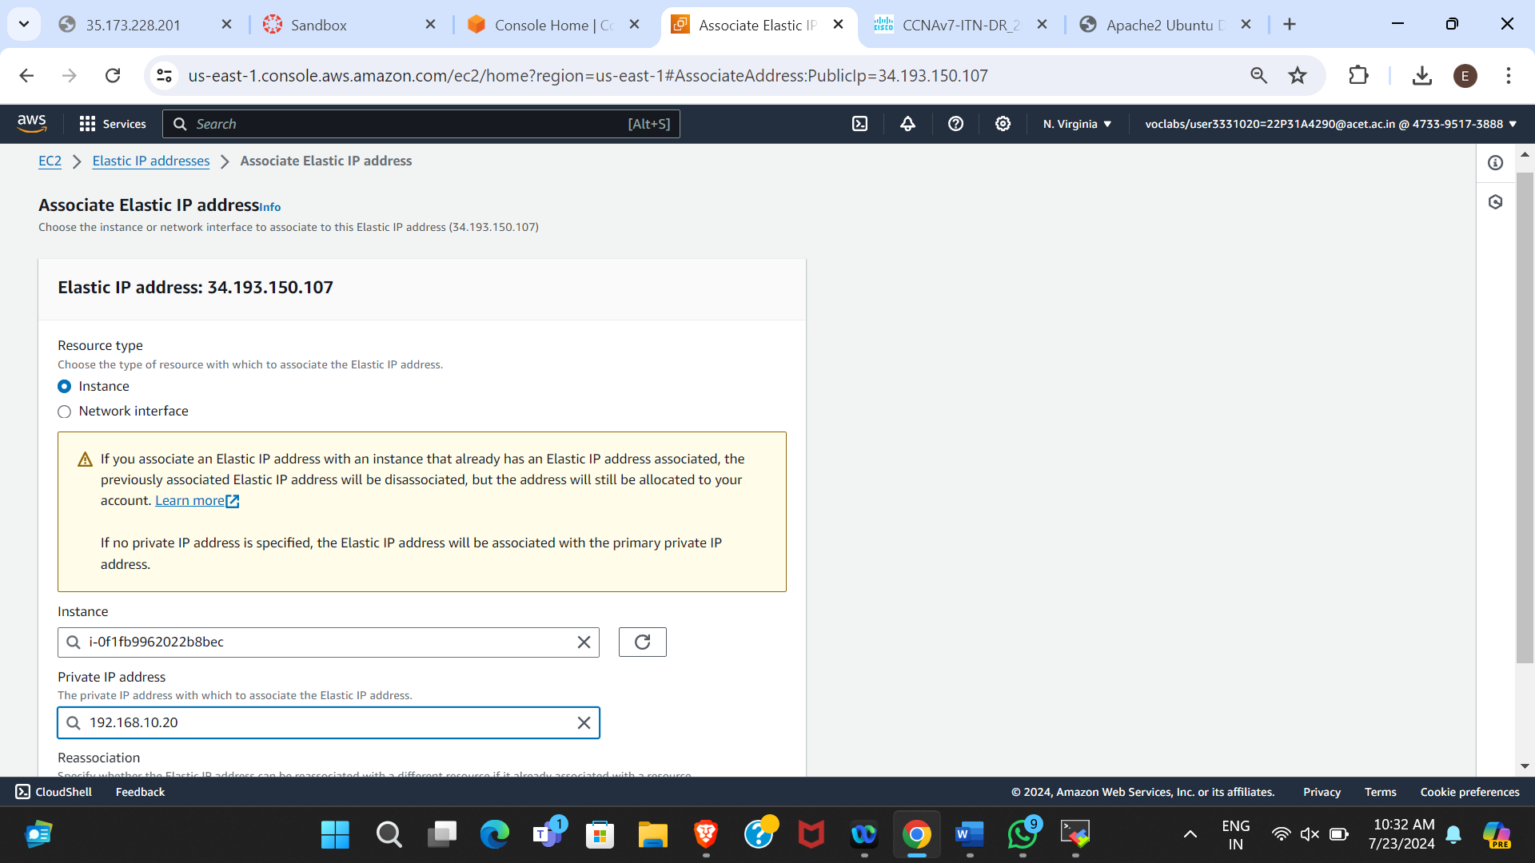

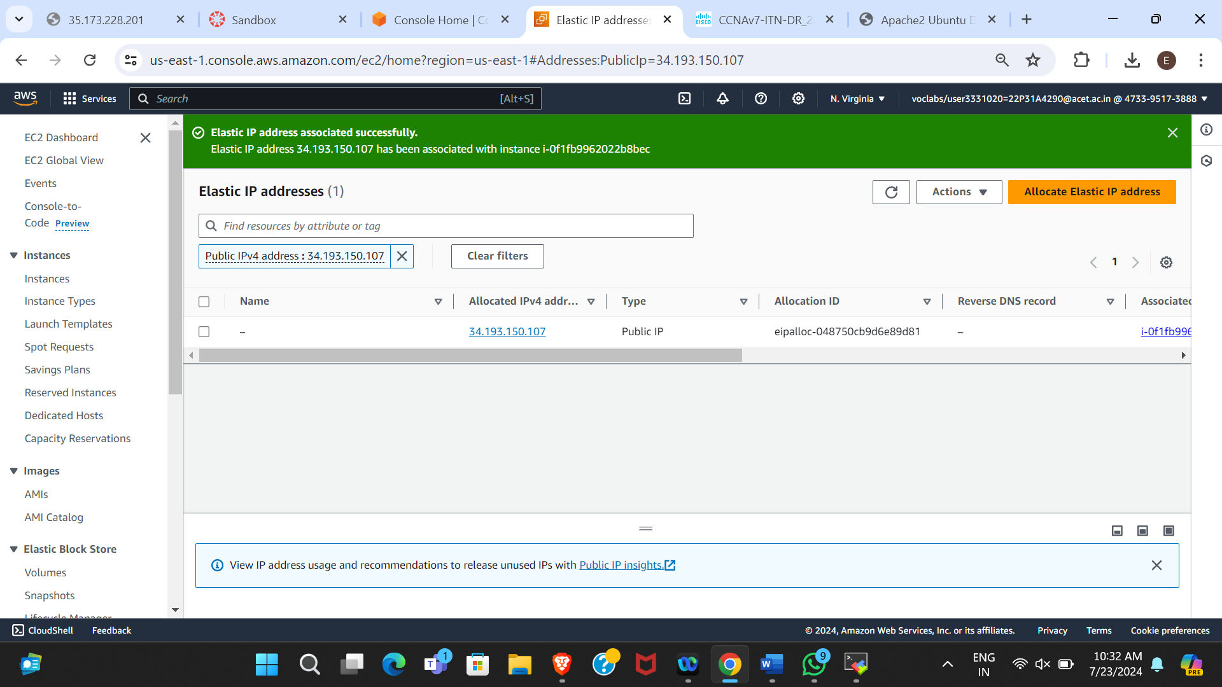

**Figure 6.10 Elastic IP address associated successfully**

9.Connect the instance to “Mobaxterm”.

* **MobaXterm**: A remote desktop software that allows user to manage remote sessions.
* Open MobaXterm and connect to your instance using SSH and the key pair you downloaded.
* Change to root user using the command **sudo su**.

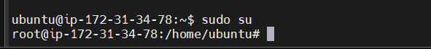

**Figure 6.11 Switch to Administrator mode**

* Update the instance (OS) before launching the application with **apt-get update**.

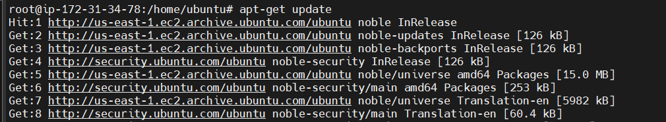

**Figure 6.12 Update the Server**

* Install the Apache web server with **apt-get install apache2**.

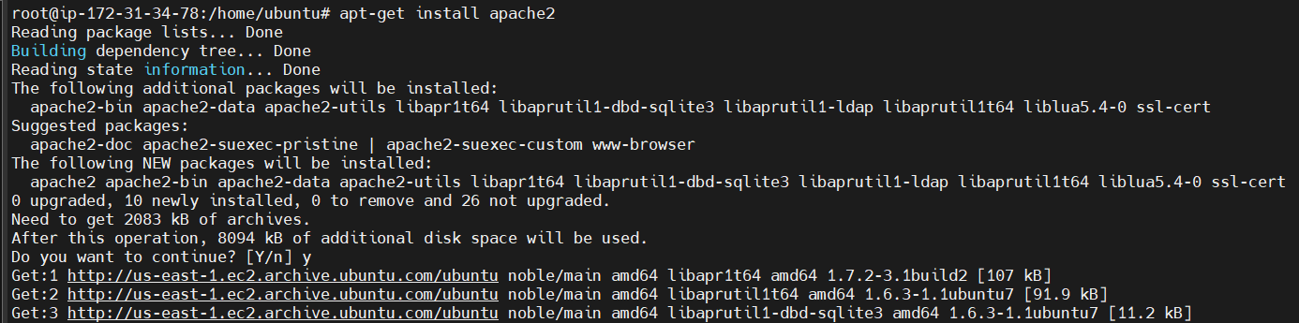

**Figure 6.13 Install Apache2 Webserver Software**

* Ensure the HTTP port is allowed in the security group settings as each server has its own port number and we can enable it in Security Groups.
* Start the Apache server with **systemctl start apache2**. You should see the default Apache Ubuntu page when you browse the public IP address.

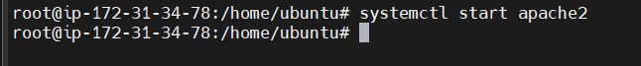

**Figure 6.14 Start Server**

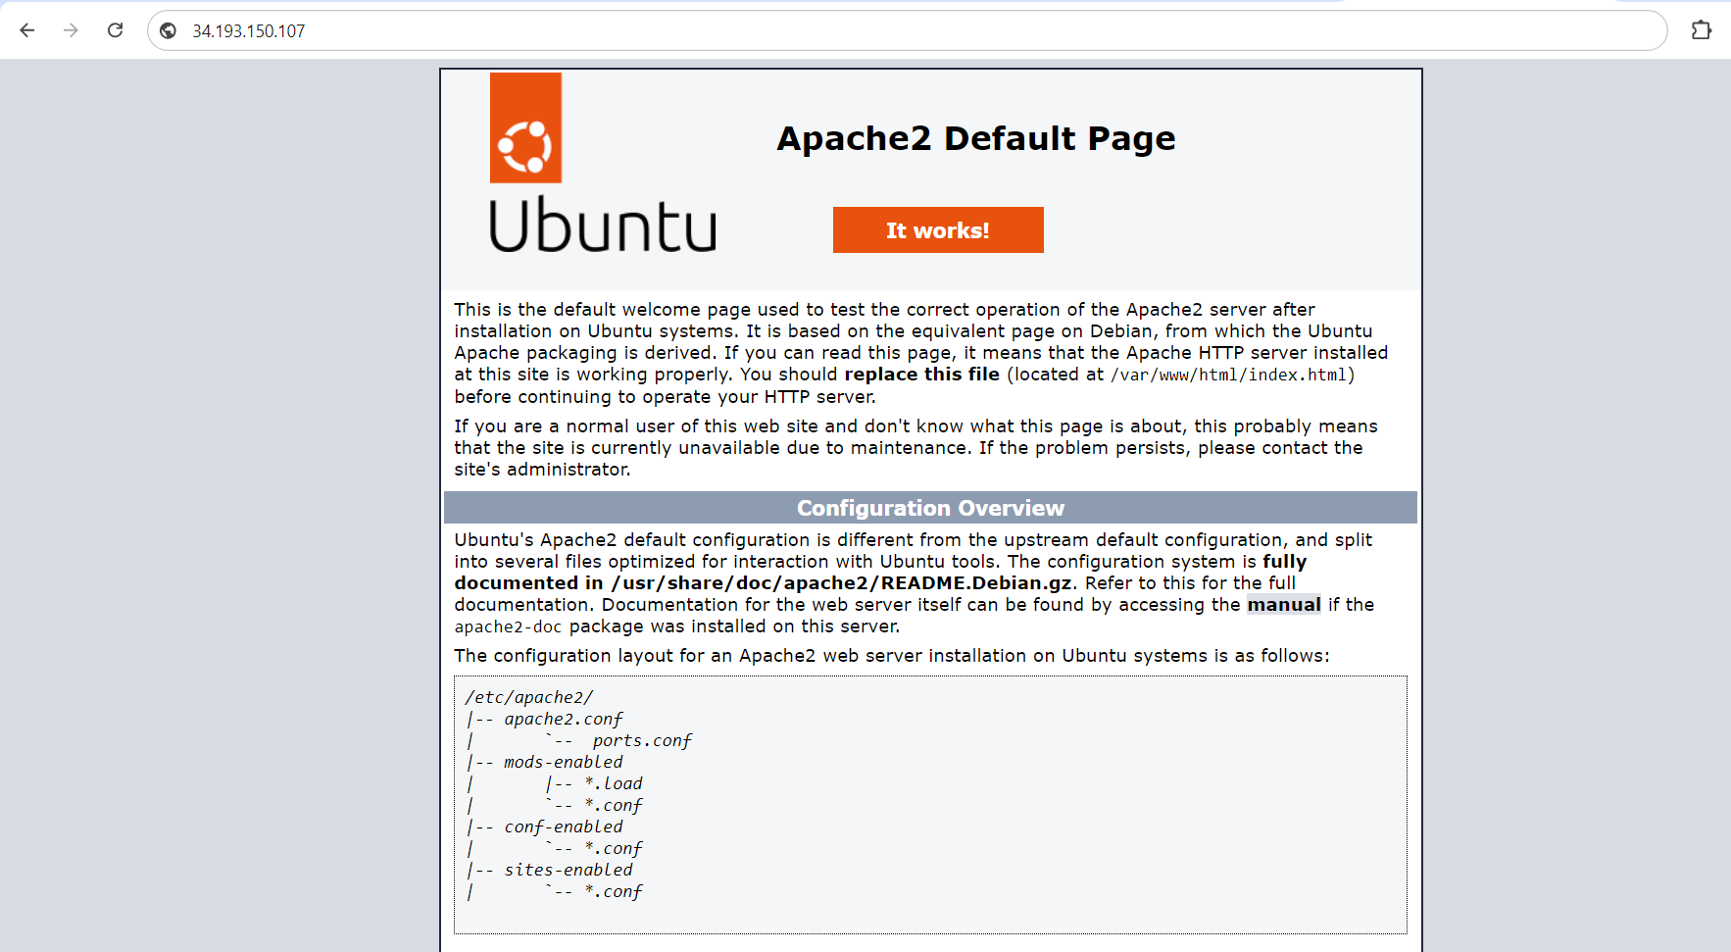

**Figure 6.15 Default Page of Ubuntu AMI**

10. Download the Ecommerce website template and upload all the files to the SFTP on the left panel at the location **/var/www/html/.** If you reload the browser you will obtain the deployed website.

* **SFTP (Secure File Transfer Protocol)**: A secure version of FTP for transferring files.
* Download the eCommerce website template.
* Use MobaXterm's SFTP to upload the files to **/var/www/html/.**
* Reload the browser to view the deployed website.

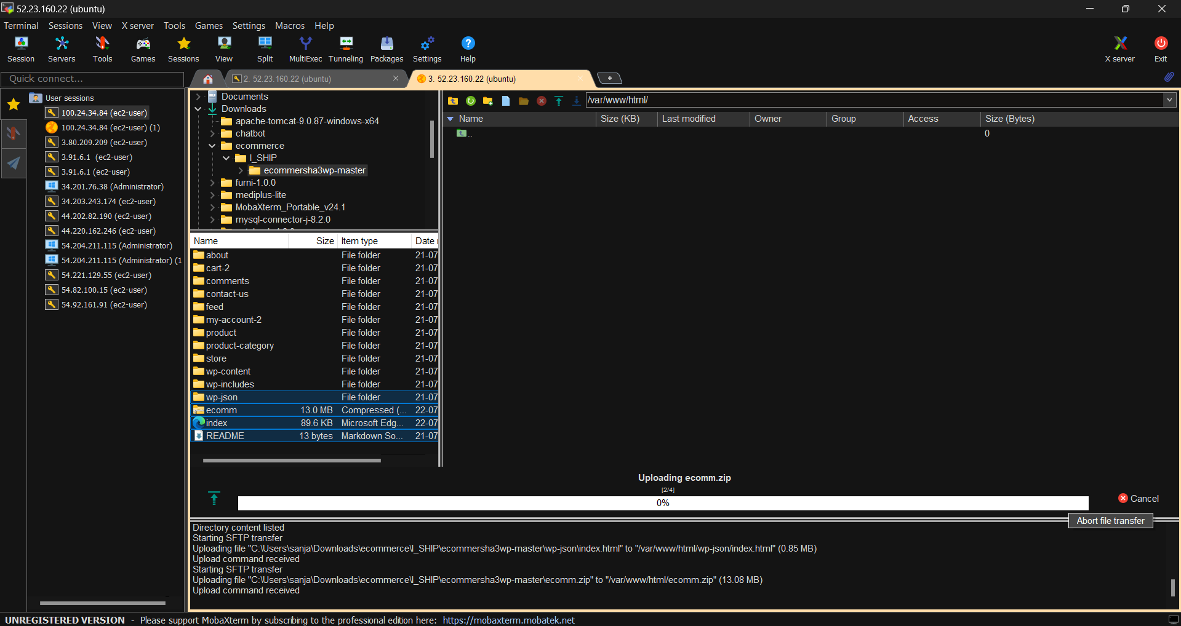

**Figure 6.16 Uploading files to SFTP**

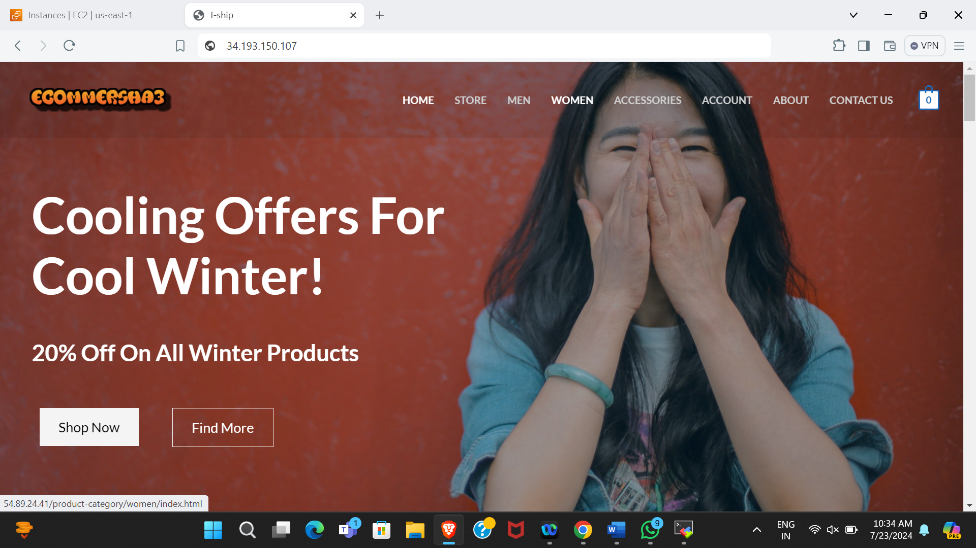

**Figure 6.17 Ecommerce webpage**

**CHAPTER 7**

**DEPLOYING AN ECOMMERCE WEBSITE**

**ON WINDOWS**

Deploying an eCommerce website on a Windows server involves several steps to ensure a secure and efficient setup. The process includes the streamlined approach ensures a robust and scalable eCommerce website deployment on Windows, leveraging the reliability and flexibility of AWS EC2.

**Steps Involved:**

1.Create another SUBNET from which you can launch the instance.

* In the VPC Dashboard, click on "Subnets" and then "Create Subnet".
* Choose the VPC you created (Iship_team2_vpc).
* Specify a name for the subnet (windows).
* Select an Availability Zone and specify a CIDR block (192.168.10.128/26).
* Click "Create Subnet".

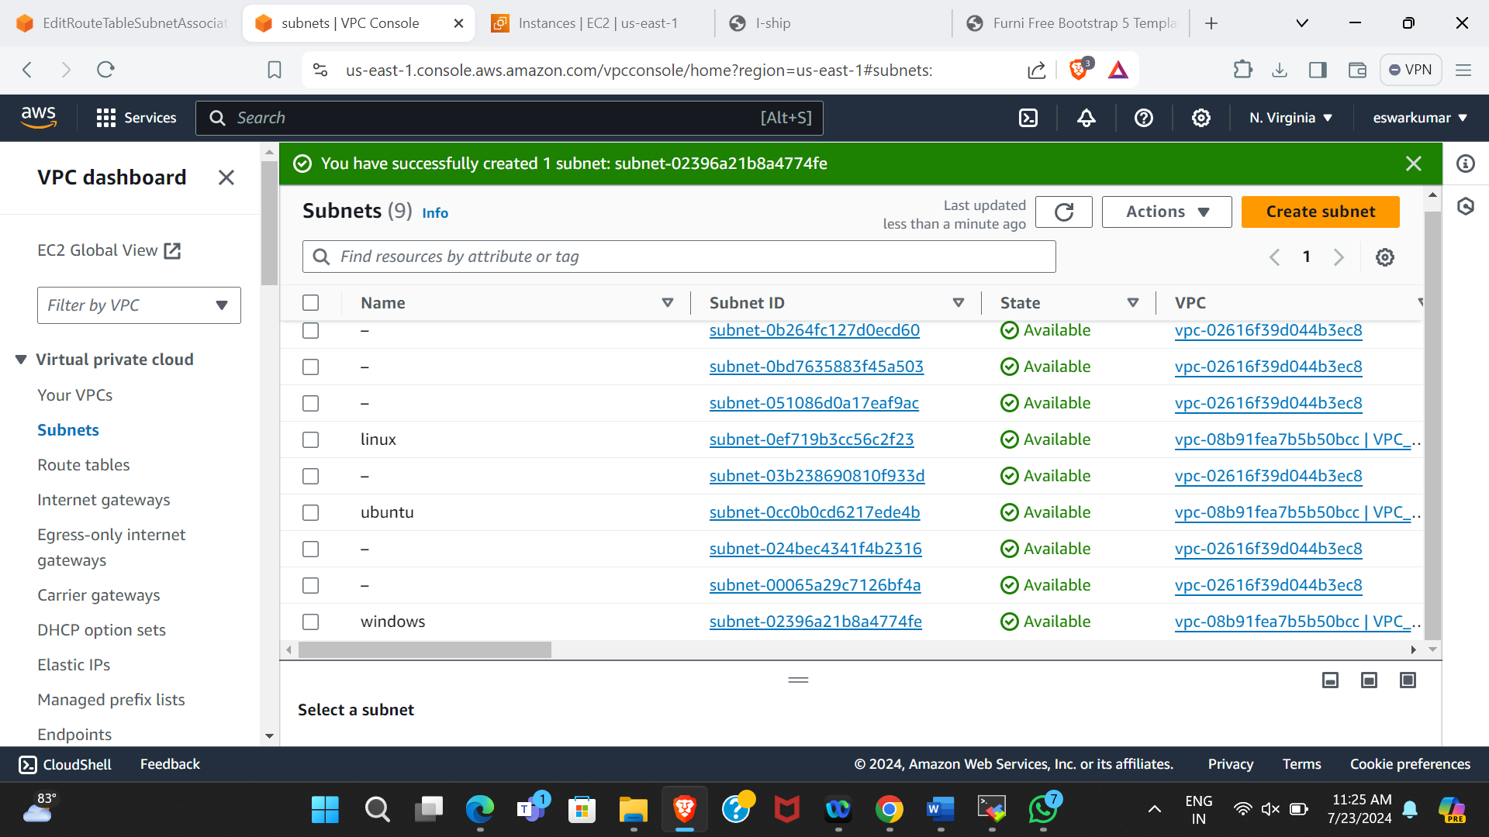

**Figure 7.1 Subnet successfully created**

2.Associate another subnet (windows) to subnet associations.

* Go to "Subnet Associations" and associate the previously created subnet (windows).

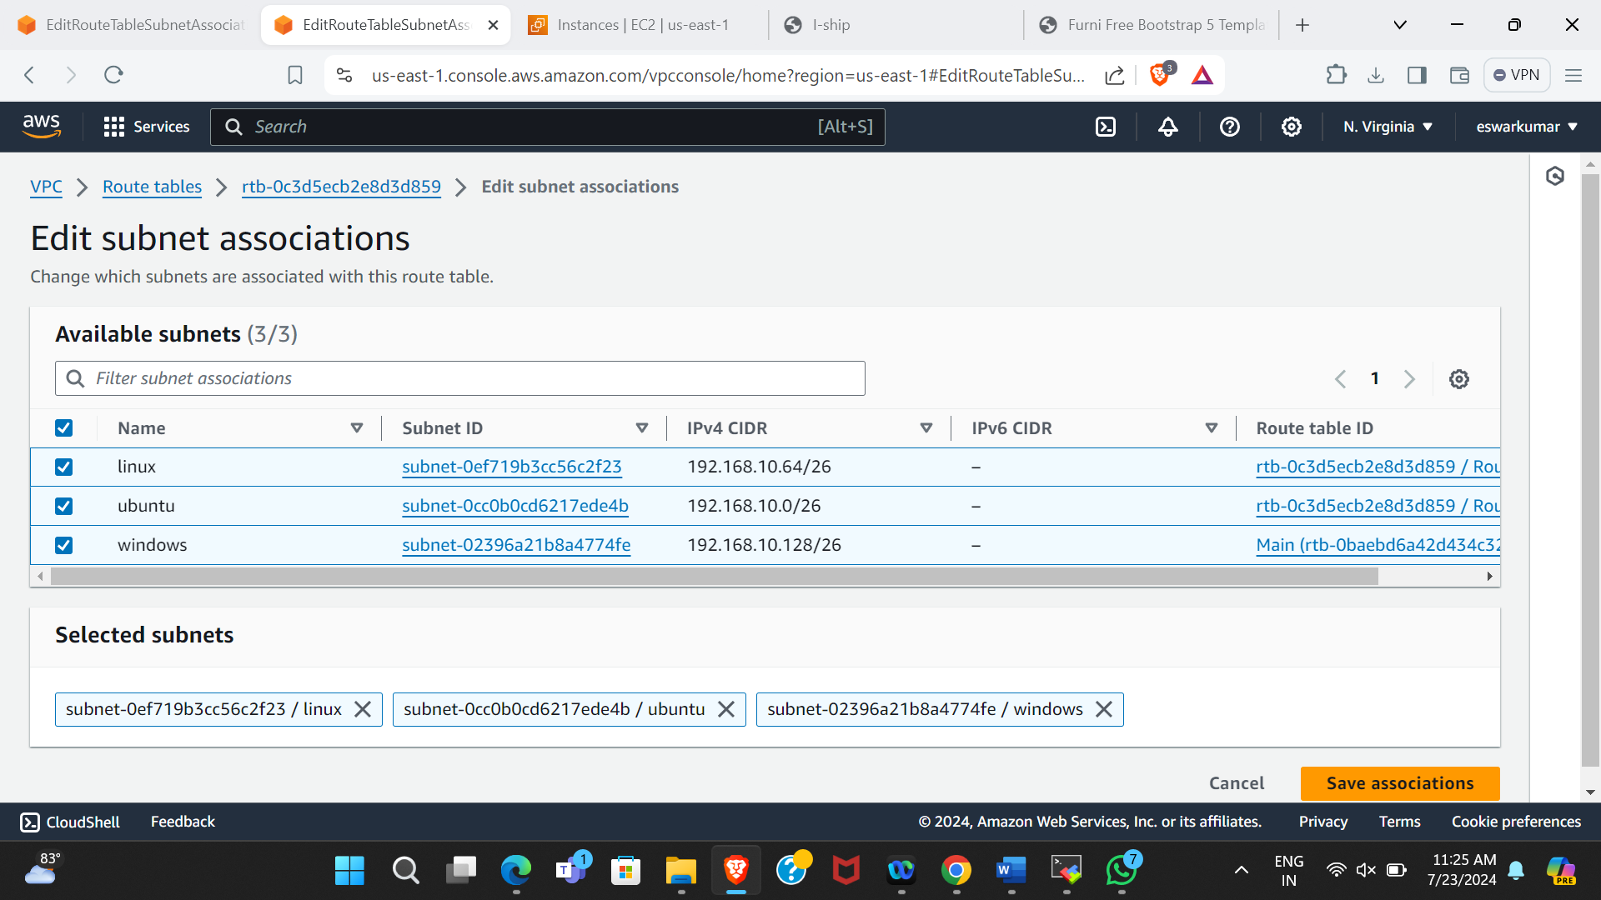

**Figure 7.2 Association of subnets to Route Table**

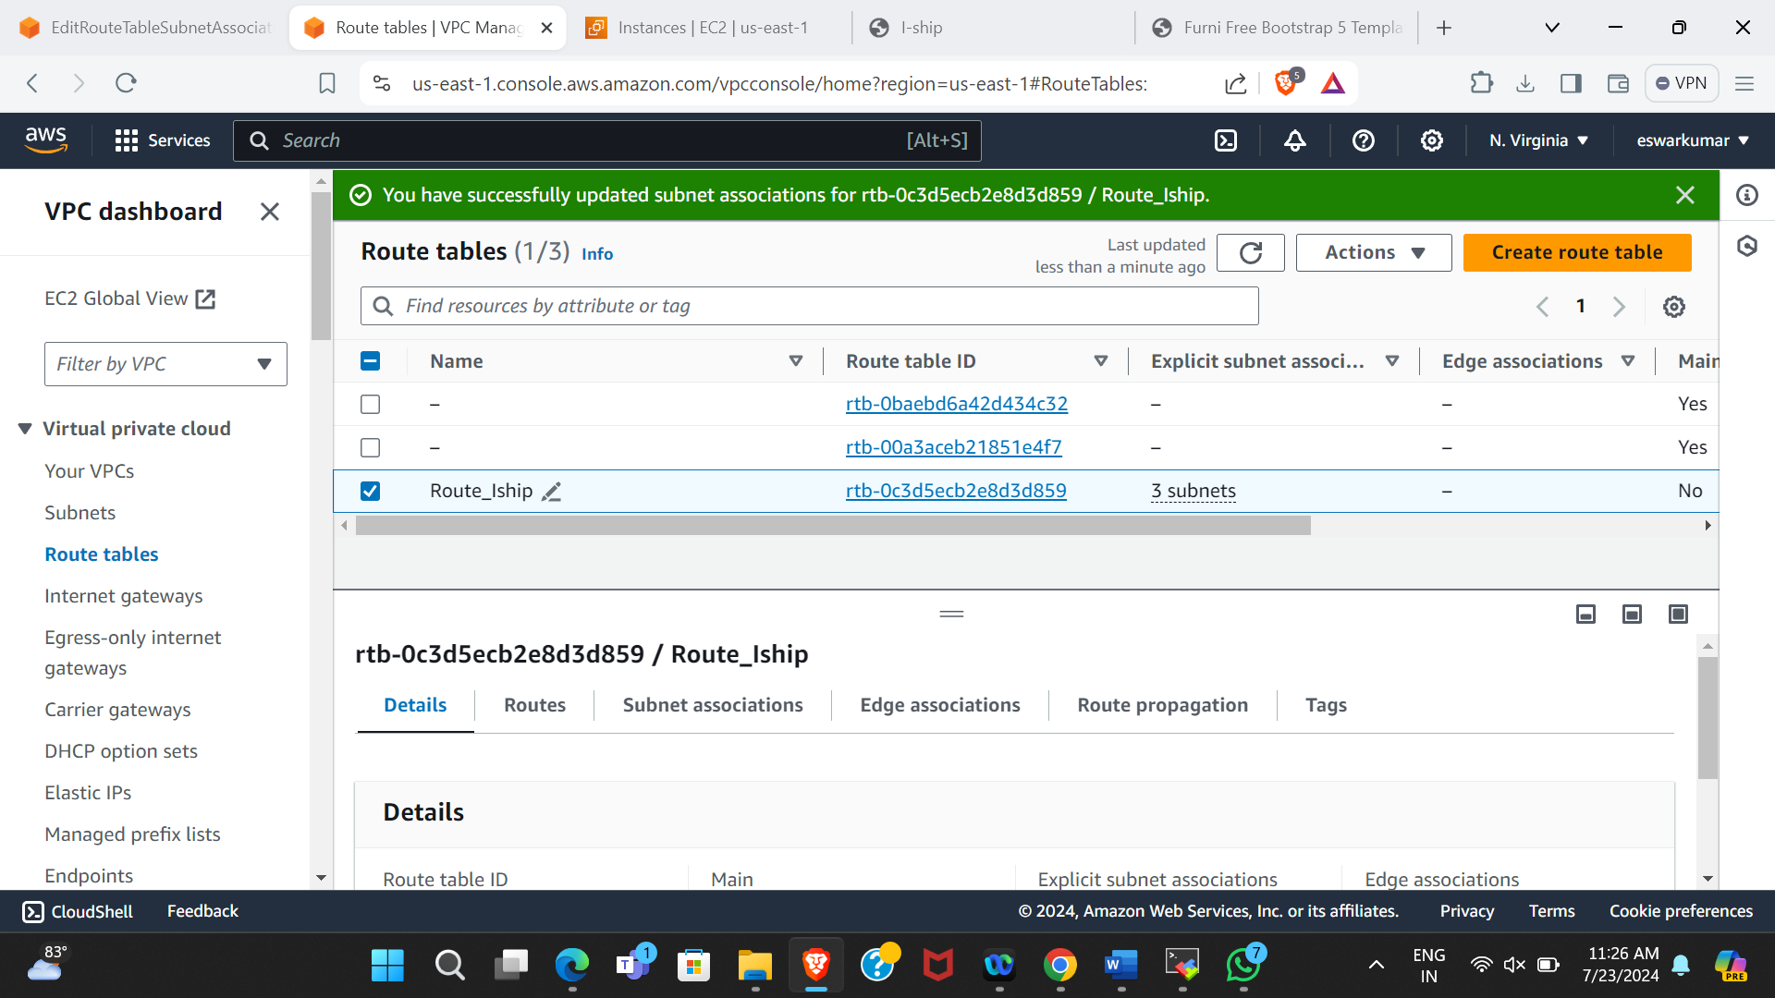

**Figure 7.3 Updating Routes in subnet**

3.Launch a EC2 instance with “WINDOWS AMI”.

* Go to the EC2 Dashboard and click “Launch Instance”.
* Choose the Windows Server AMI (Microsoft Windows Server 2022).
* Select an instance type (t2.micro, which is eligible for the free tier).
* Download the key pair to securely connect to your instance.
* Edit the network settings:
  + Select the VPC (Iship_team2_vpc) and subnet (window).
  + Enable auto-assigned public IP.
* Configure instance details, add storage, and configure security groups (allow HTTP, HTTPS, and SSH). Review and launch the instance.

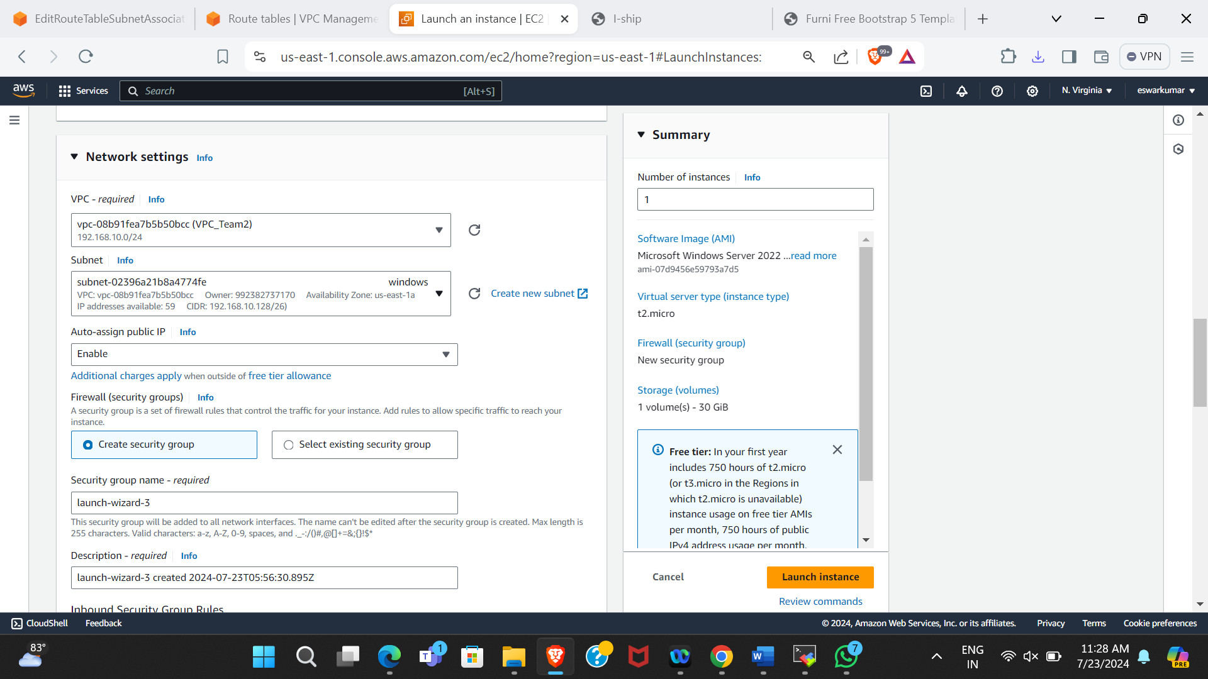

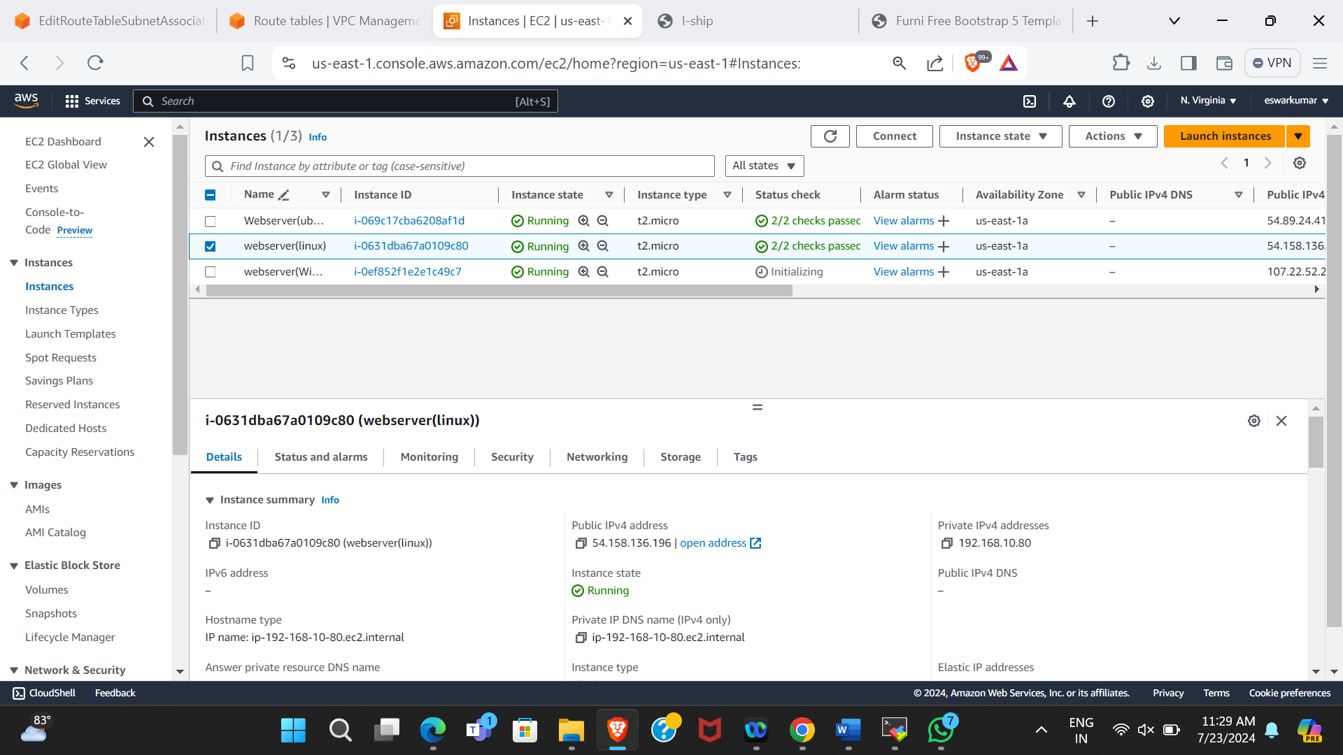

**Figure 7.4 Instance launched successfully**

4.Connect the instance to “Mobaxterm”.

#### **Obtain the Administrator Password**

* Go to the AWS Management Console.
* Navigate to the EC2 Dashboard.
* Select the instance you launched and click on "Connect".
* Choose "RDP Client".
* Click on "Get Password".
* Upload your key pair file (.pem) and decrypt the password.

#### **Set Up a New RDP Session in MobaXterm**

* In MobaXterm, click on the "Session" icon in the top left corner.
* Select "RDP" from the list of session types.
* Fill in the following details:

|  |  |
| --- | --- |
| **Remote Host** | The public IP address of your EC2 instance. |
| **Username** | Administrator. |
| **Password** | The password you obtained from AWS |

* Click "OK" to start the session.

#### **Configure IIS (Internet Information Services)**

* **IIS**: A flexible, secure, and manageable Web server for hosting anything on the Web.
* Once connected, you will be in a new Windows virtual machine.
* Open the "Server Manager" from the Start menu.
* Click on "Add roles and features".
* Proceed with the default settings in the wizard until you reach the "Server Roles" page.
* Check the box for "Web Server (IIS)".
* Continue with the default settings and install.

#### **Confirm Installation and Verify IIS**

* Once the installation is complete, you will see a message "SERVER INSTALL SUCCEEDED".
* Open a web browser within the virtual machine.
* Enter the public IP address of your instance in the address bar.
* You should see the default IIS welcome page, confirming that IIS is installed and running.

#### **Deploy Your Website**

* Open "File Explorer" and navigate to **C:\inetpub\wwwroot\**.
* Replace the existing files with your website files. You can drag and drop the files into this directory.

#### **Verify Deployment**

* Reload the public IP address in the browser.
* You should now see your deployed website.

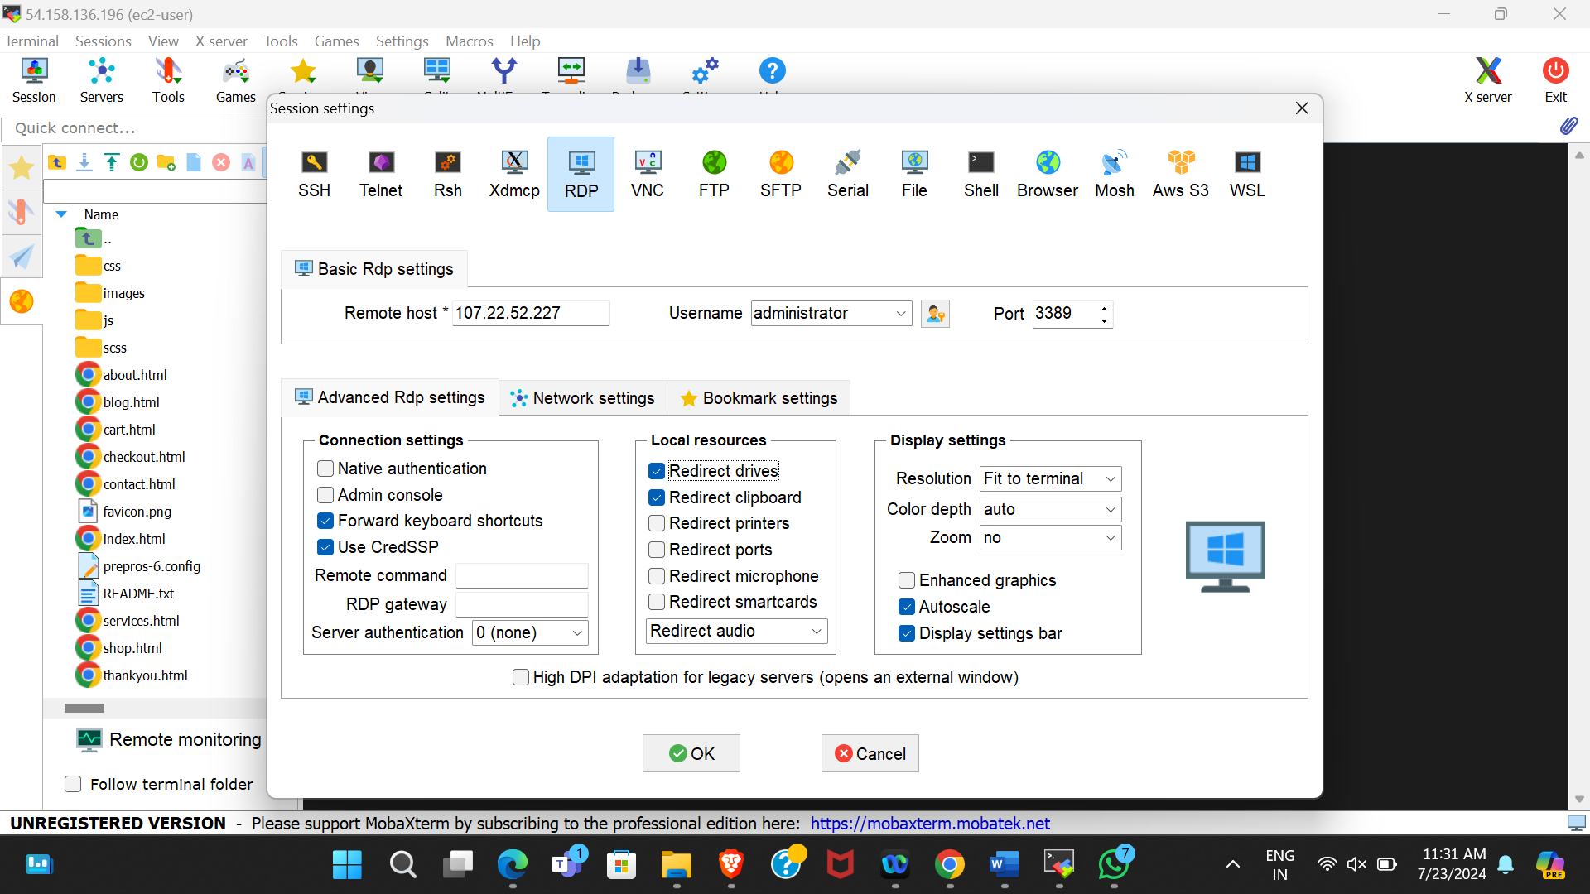

**Figure 7.5 Connecting to mobaXterm**

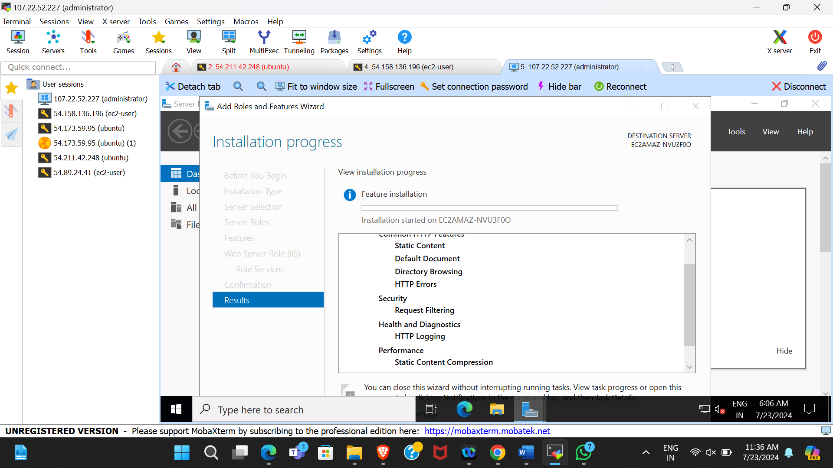

**Figure 7.6 Launching the default server**

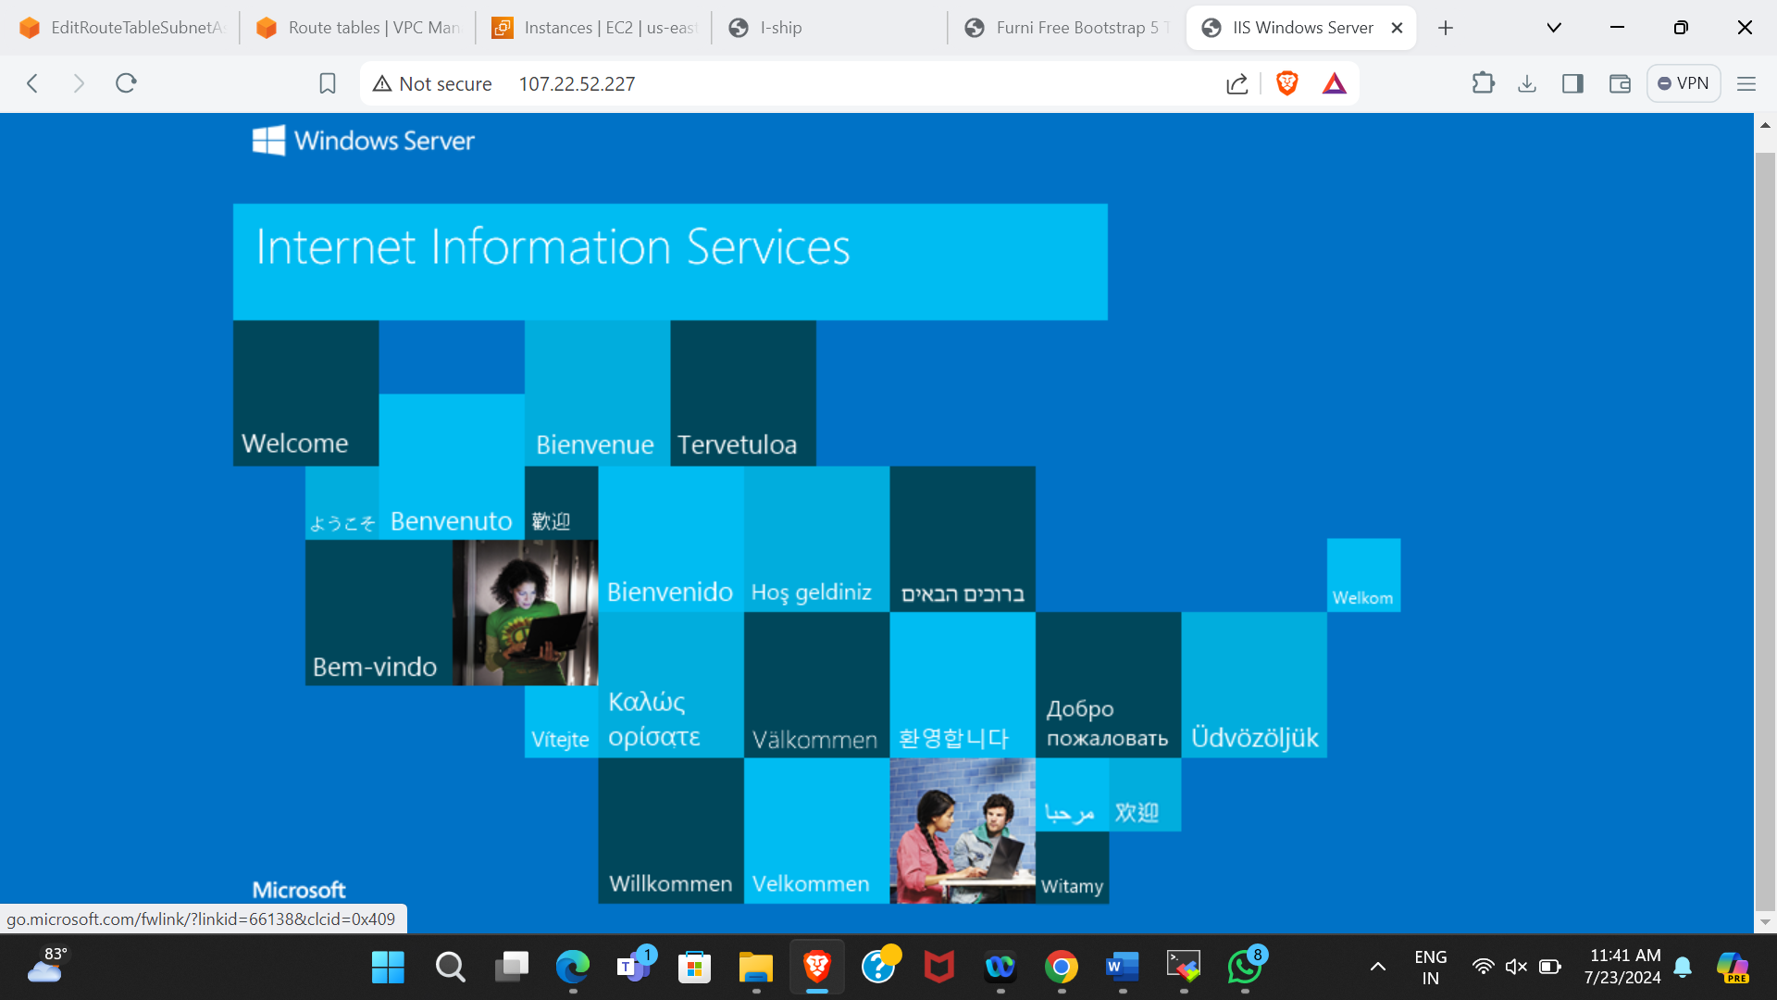

**Figure 7.7 Windows Default webpage**

5.Deploy the download the Ecommerce website template.

#### **Deploy Your Website**

* Open "File Explorer" and navigate to **C:\inetpub\wwwroot\**.Replace the existing files with your website files. You can drag and drop the files into this directory.

#### **Verify Deployment**

* Reload the public IP address in the browser. You should now see your deployed website.

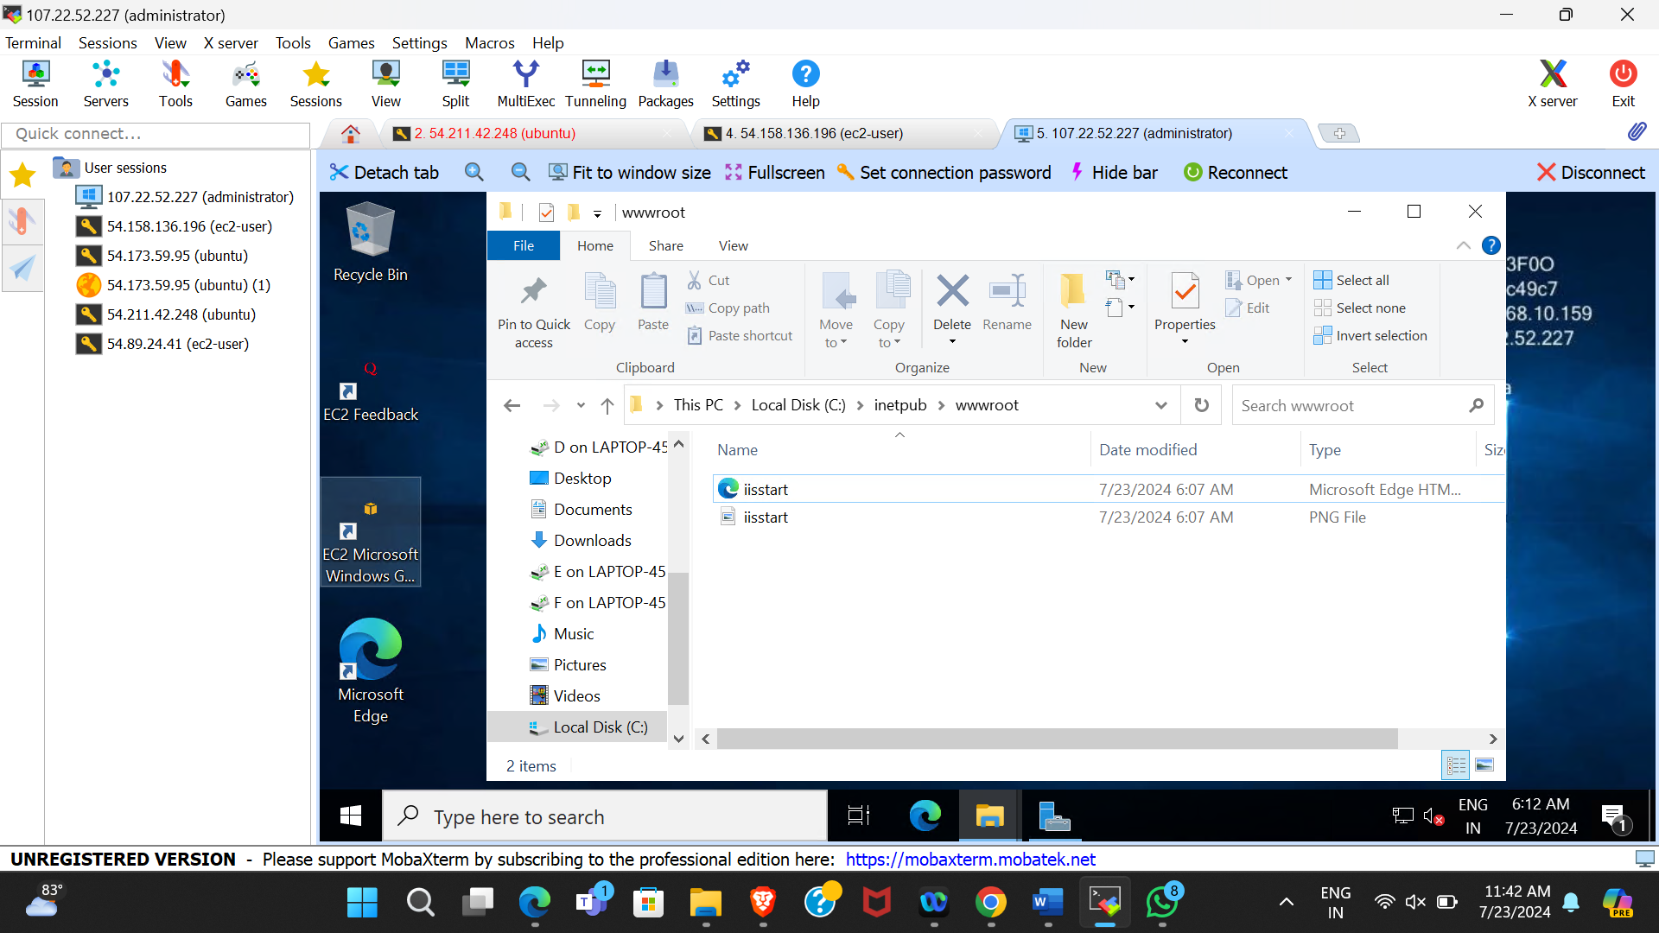

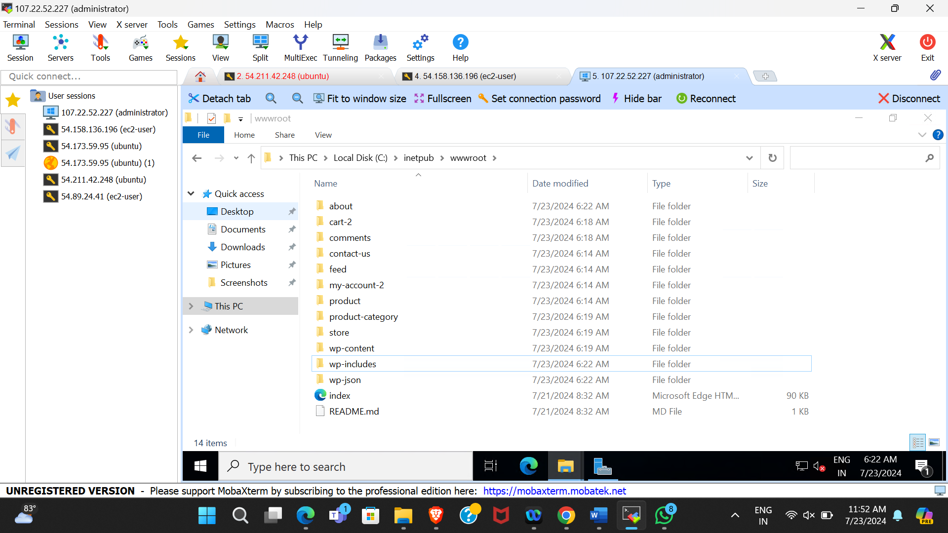

**Figure 7.8 Upload files to c:\inetput\wwwroot\**

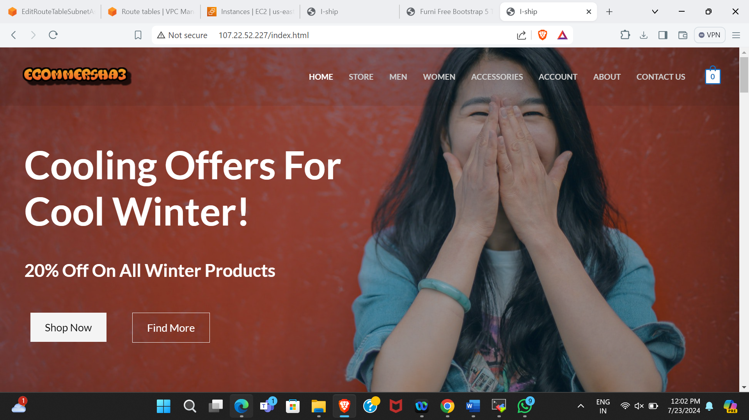

**Figure 7.9 Ecommerce webpage**

**CHAPTER 8**

**DEPLOYING AN ECOMMERCE WEBSITE**

**ON ELASTIC BEAN STALK**

1.Login to AWS Management Console and go to the VPC Dashboard.

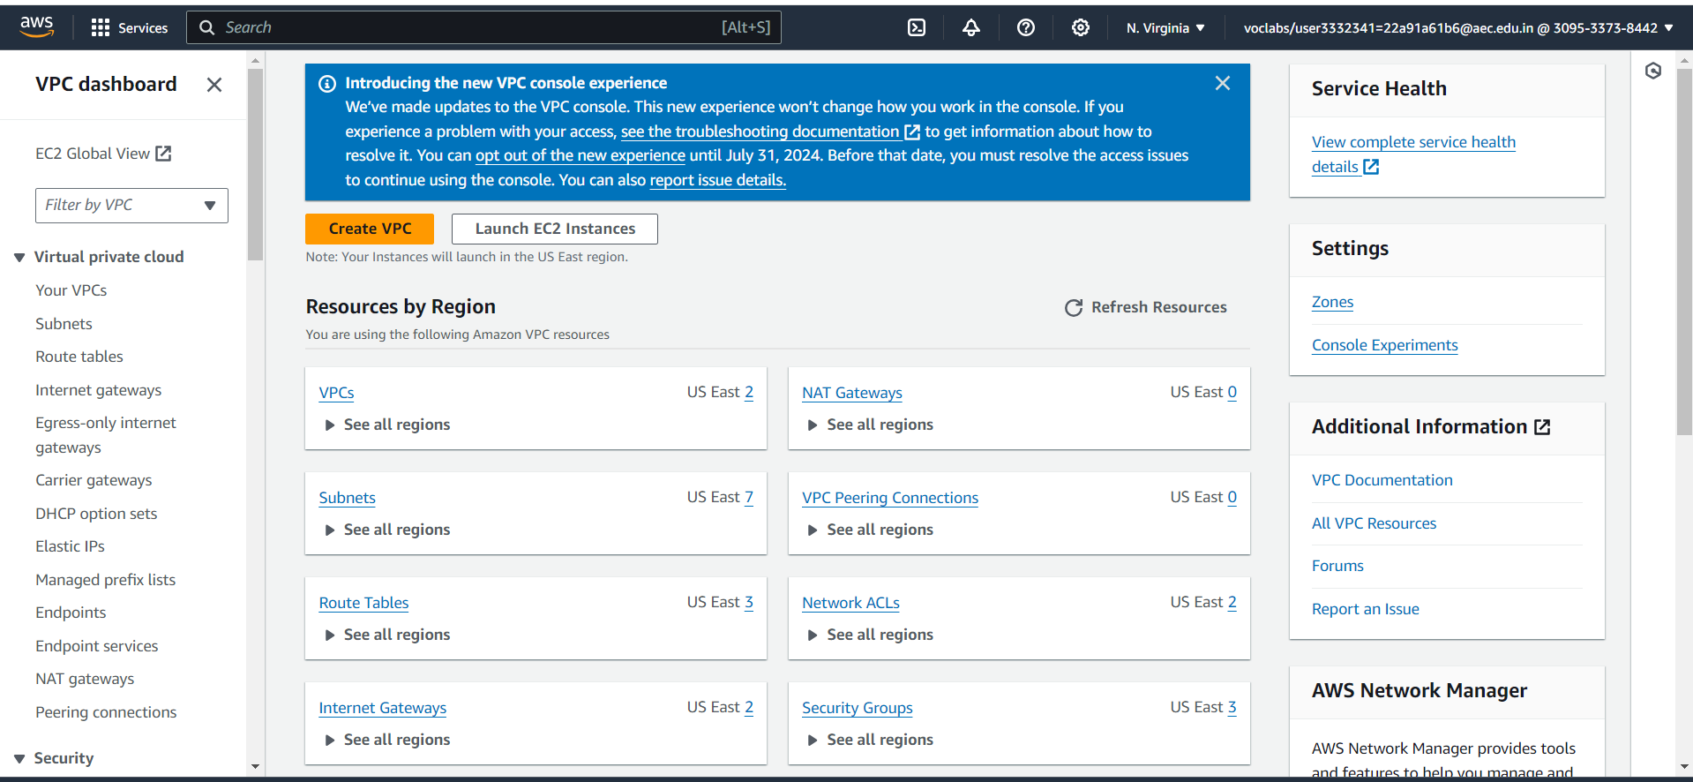

**Figure 8.1 VPC dashboard**

2.Create a VPC

* Go to the VPC Dashboard. Click on "Create VPC".
* Specify a name for your VPC and an IPv4 CIDR block (e.g., 192.168.10.0/24).
* Click "Create VPC".

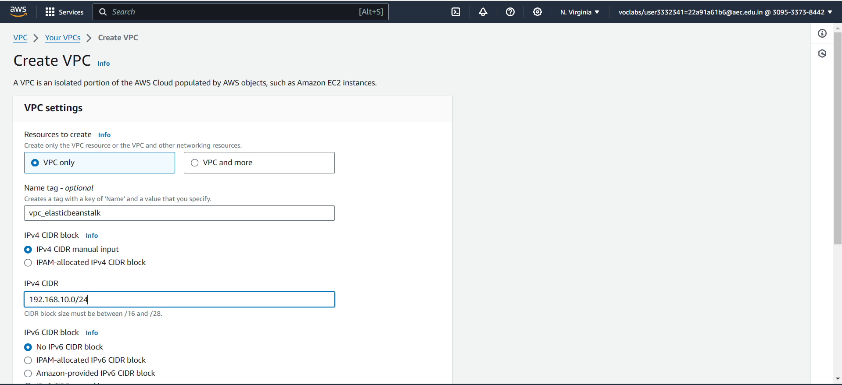

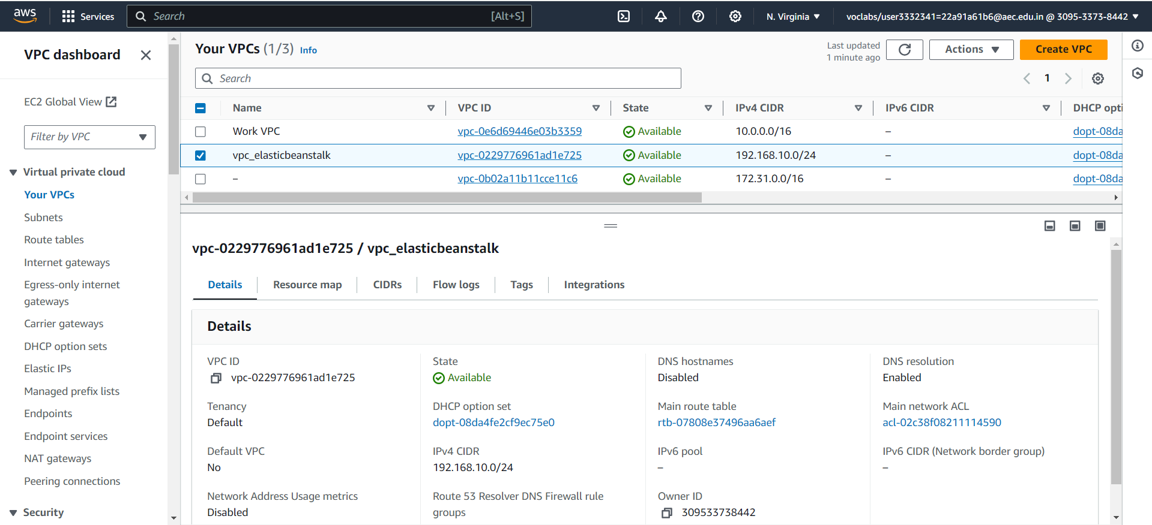

**Figure 8.2 VPC successfully created**

3.Create another SUBNET from which you can launch the instance.

* In the VPC Dashboard, click on "Subnets" and then "Create Subnet".
* Choose the VPC you created (vpc_elasticbeanstalk).
* Specify a name for the subnet (subnet_elasticbeanstalk).
* Select an Availability Zone and specify a CIDR block (192.168.10.64/26).
* Click "Create Subnet".

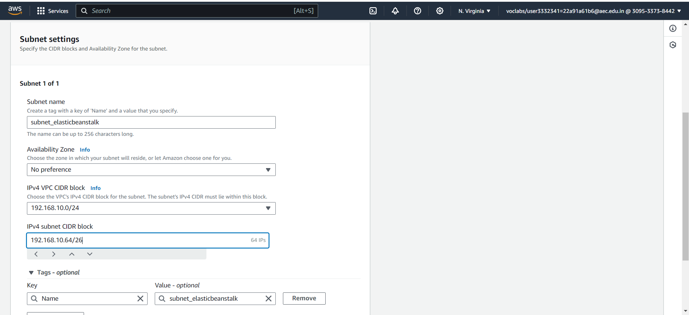

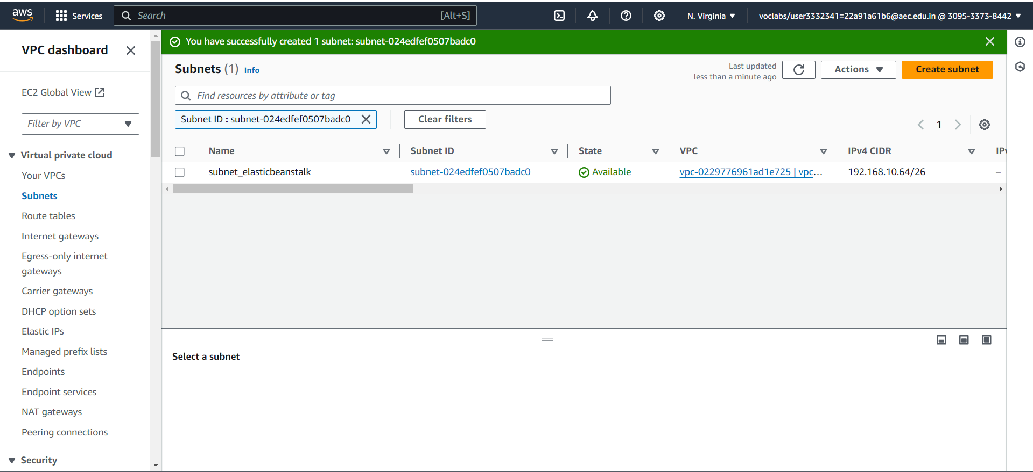

**Figure 8.3 Subnet successfully created**

4.Create an INTERNET GATEWAY.

* In the VPC Dashboard, click on "Internet Gateways" and then "Create Internet Gateway".
* Name the Internet Gateway and click "Create".

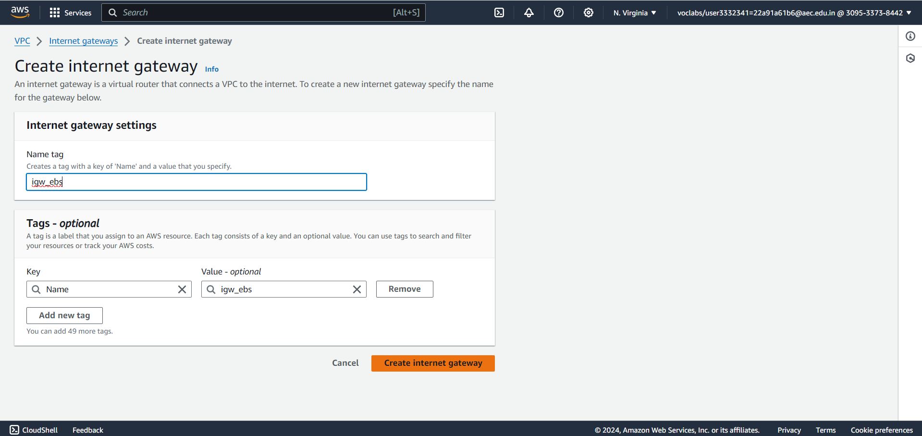

**Figure 8.4 Internet Gateway created successfully**

5.Attach the GATEWAY to VPC.

* Select the created Internet Gateway.
* Click on "Actions" and then "Attach to VPC".
* Select your VPC (e.g., vpc_elasticbeanstalk) and click "Attach Internet Gateway".

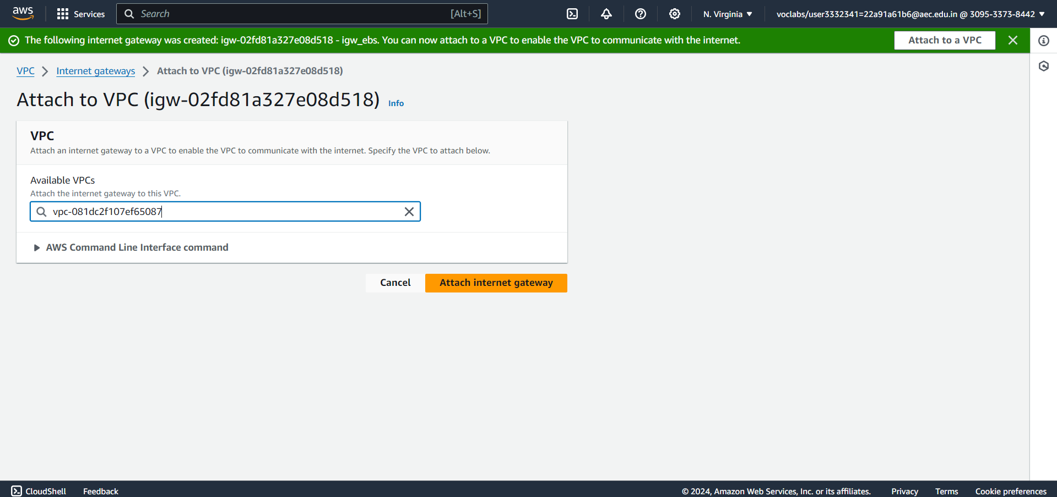

**Figure 8.5 Internet Gateway successfully attached to VPC**

6**.** Deploy Your Application Using Elastic Beanstalk

* **Elastic Beanstalk**: A platform as a service (PaaS) offered by AWS that allows easy deployment and scaling of web applications and services.
* Go to the Elastic Beanstalk dashboard.
* Click on "Create a new environment".
* Select "Web server environment" and click "Select".
* Fill in the application information and environment details:

|  |  |
| --- | --- |
| **Application name** | Provide a name for your application. |
| **Environment name** | Provide a name for your environment. |
| **Platform** | Choose the appropriate platform (e.g., "Python", “tomcat”, etc., based on your application). |
| **Application code** | Upload your eCommerce website code (as a zip file). |

* Click "Next".

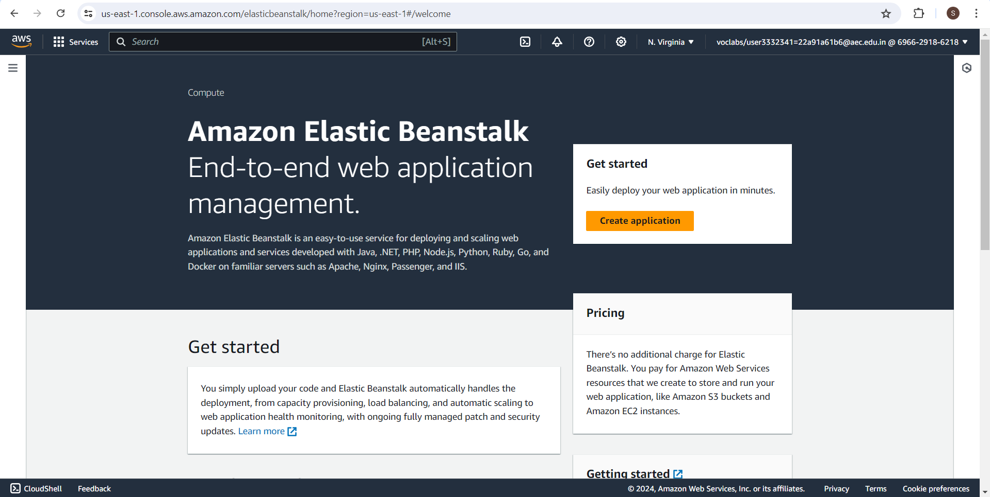

**Figure 8.6 Elastic Beanstalk environment**

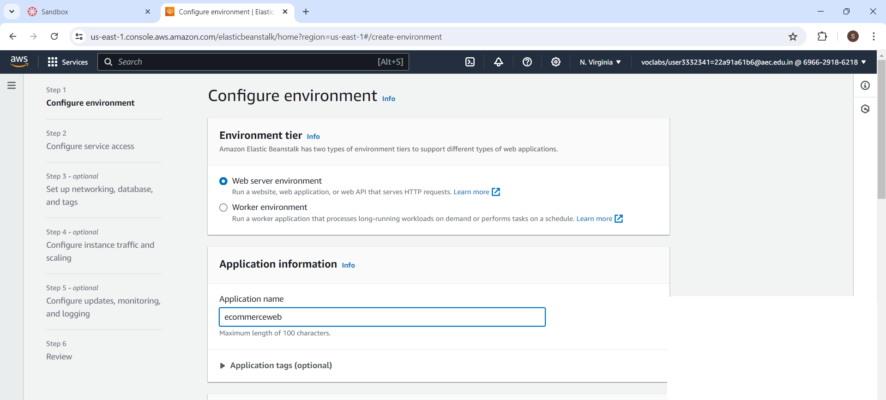

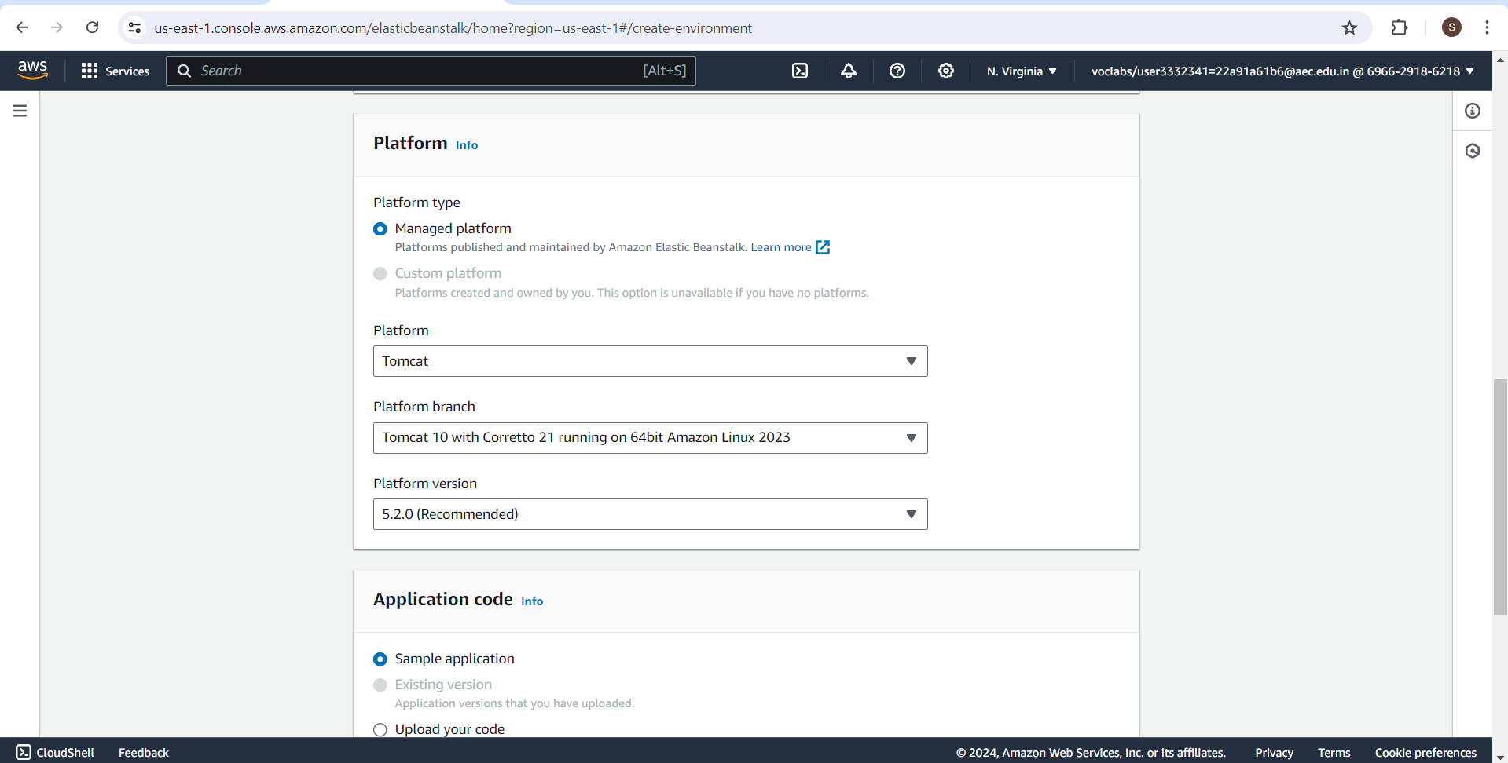

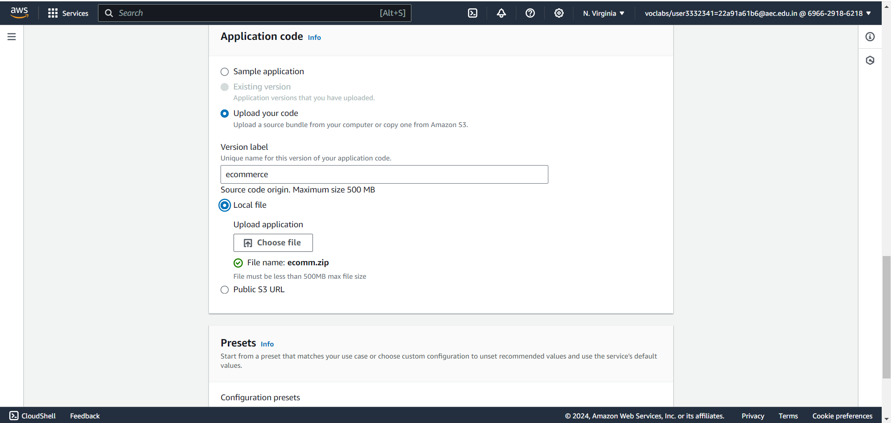

**Figure 8.7 Configure Environment**

* Go to “configure service access”.
* Fill in the service access information:

|  |  |
| --- | --- |
| **Existing Service Role** | EC2InstanceRole |
| **EC2 key pair** | Vockey |
| **EC2 instance profile** | LaunchinstanceProfile |

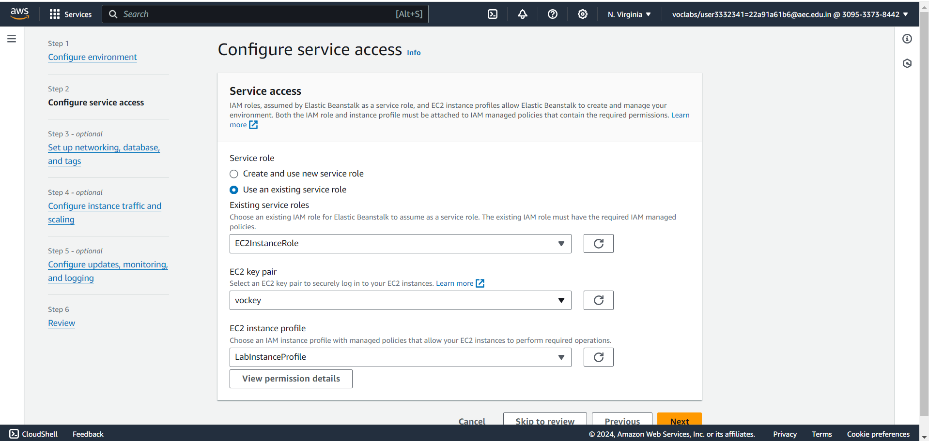

**Figure 8.8 Configure service access**

* Go to “setup networking and database”.
* Select the vpc (vpc_elasticbeanstalk) and subnet (subnet_elasticbeanstalk) created.

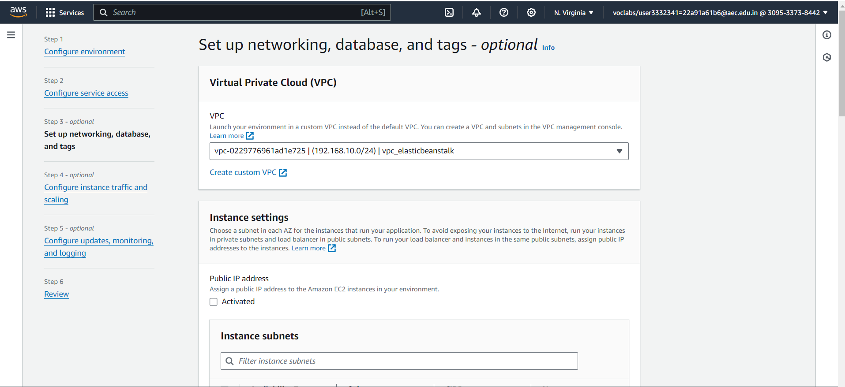

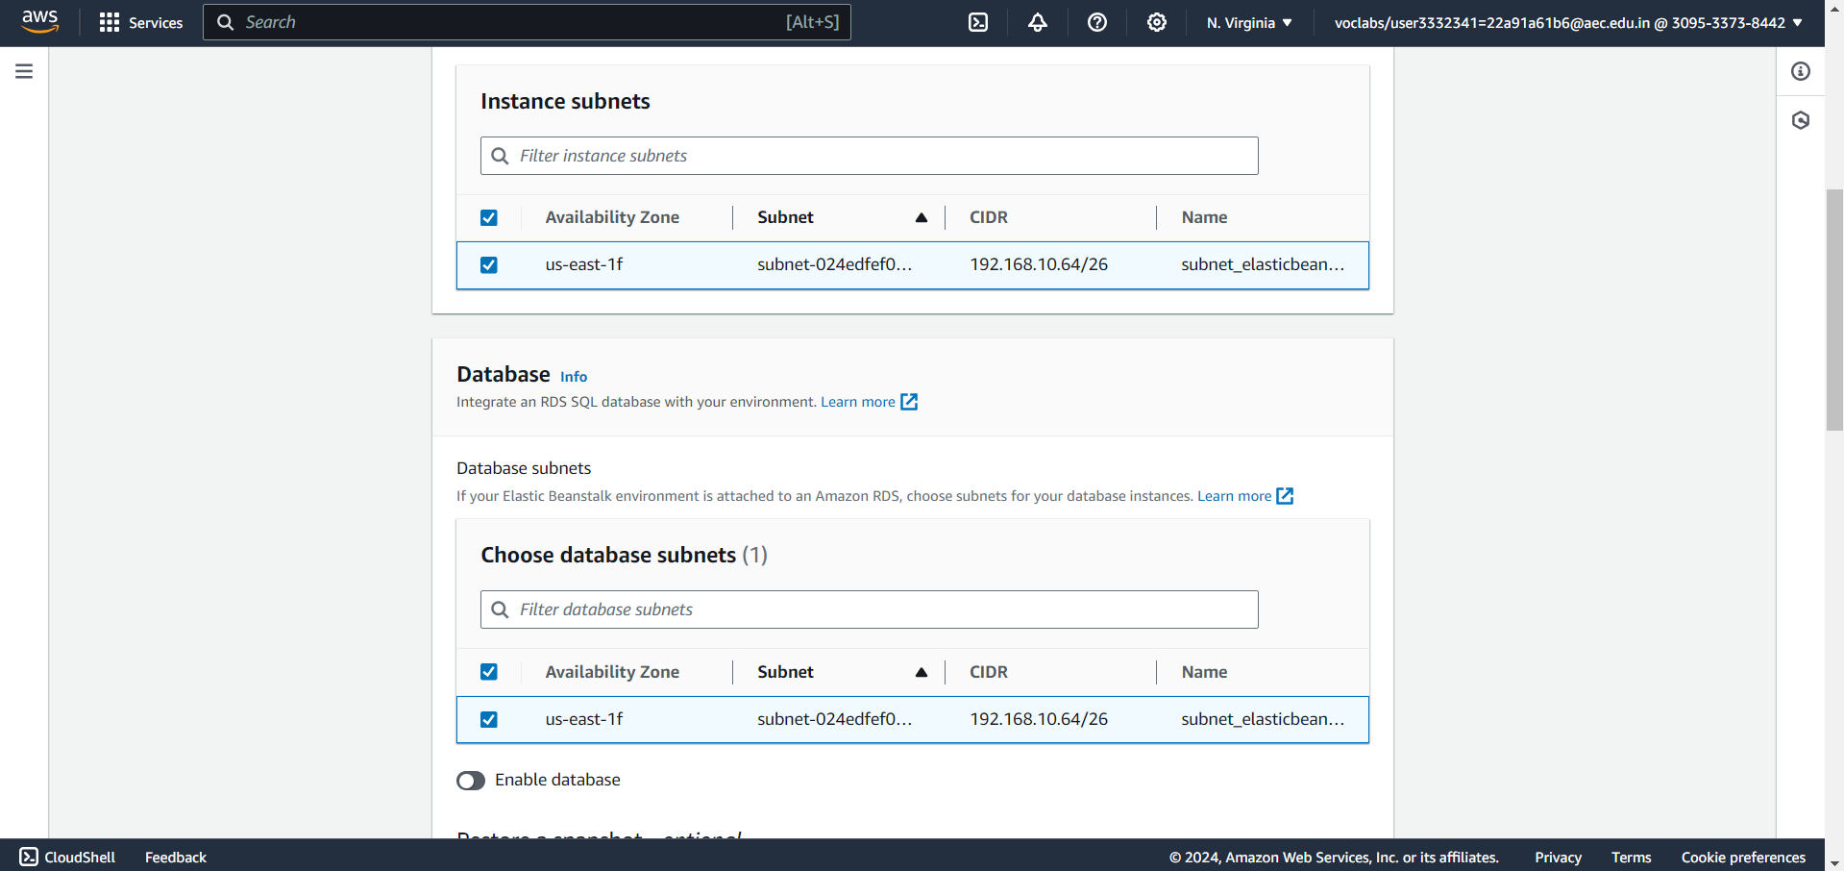

**Figure 8.9 Setup networking and databases**

* Elastic Beanstalk will automatically handle the details of capacity provisioning, load balancing, scaling, and application health monitoring.

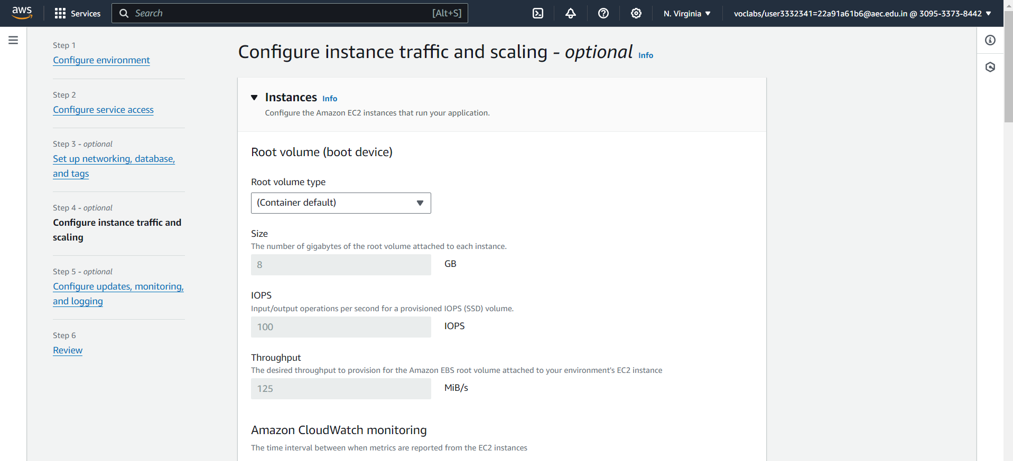

**Figure 8.10 Configure instance traffic and scaling**

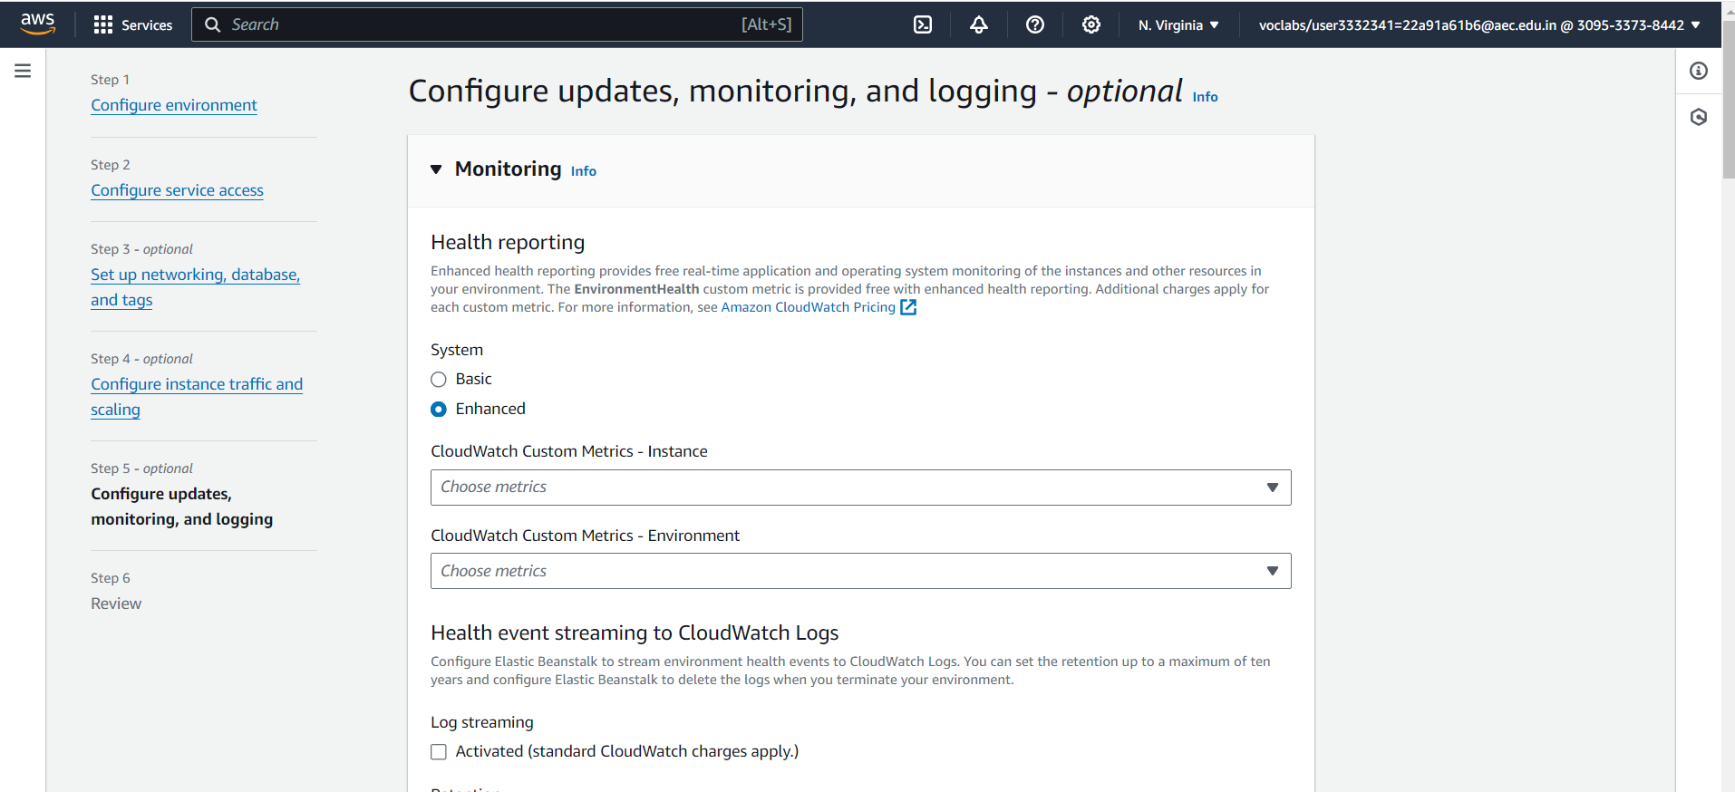

**Figure 8.11 Configure update, monitoring and logging**

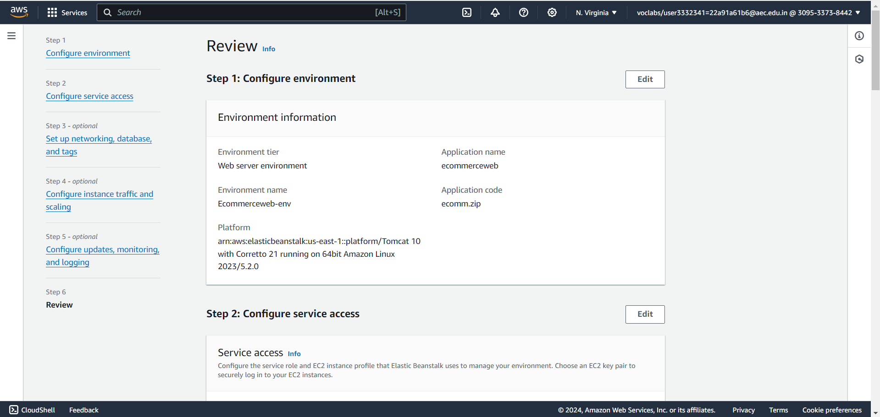

**Figure 8.12 Review**

* Click "Create environment".

7. Access Your Application

* Once the environment is created, Elastic Beanstalk will provide a URL to access your application.

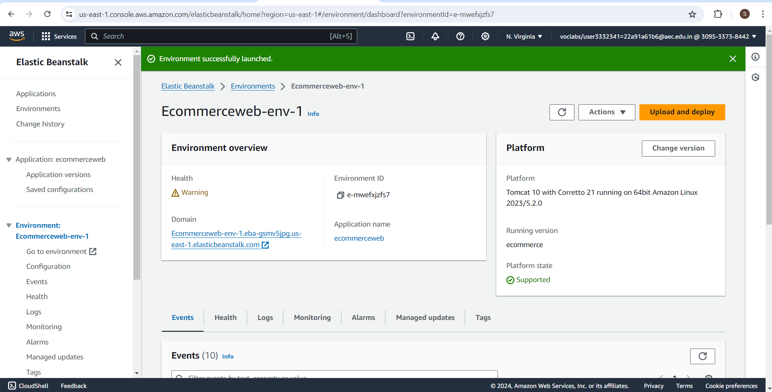

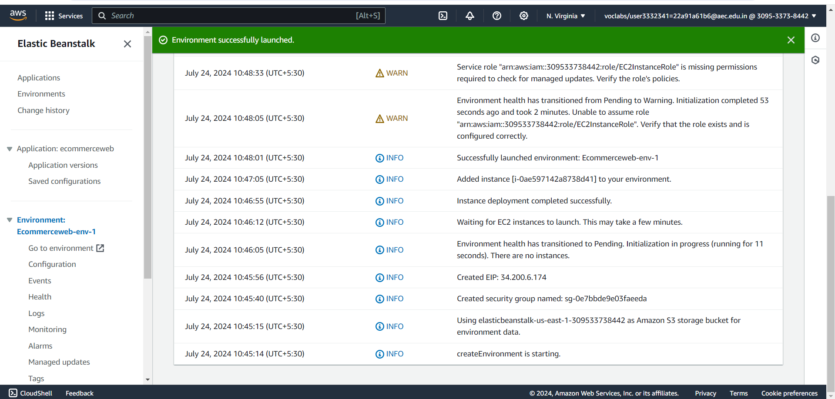

**Figure 8.13 Environment successfully Launched**

* A instance will be created with the given version name.

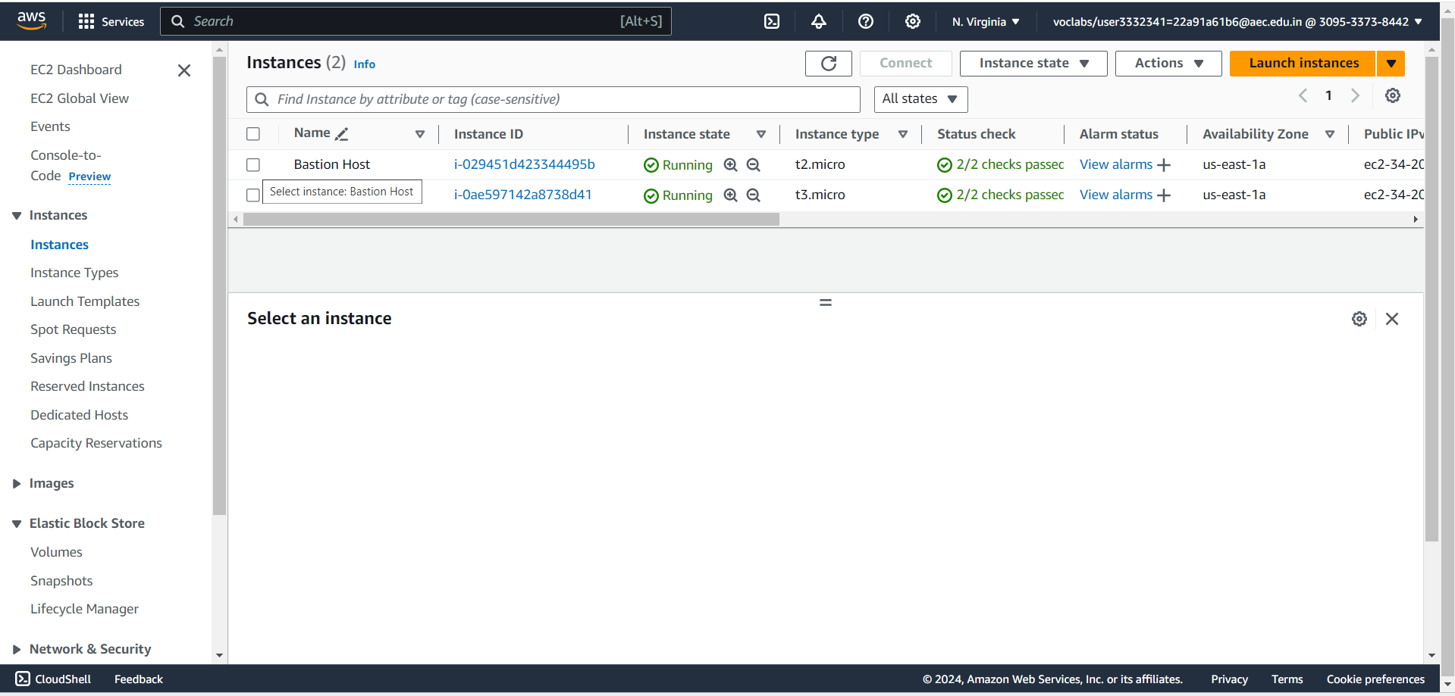

**Figure 8.14 Instance created by environment**

* Open a web browser and navigate to the provided URL to view your deployed website.

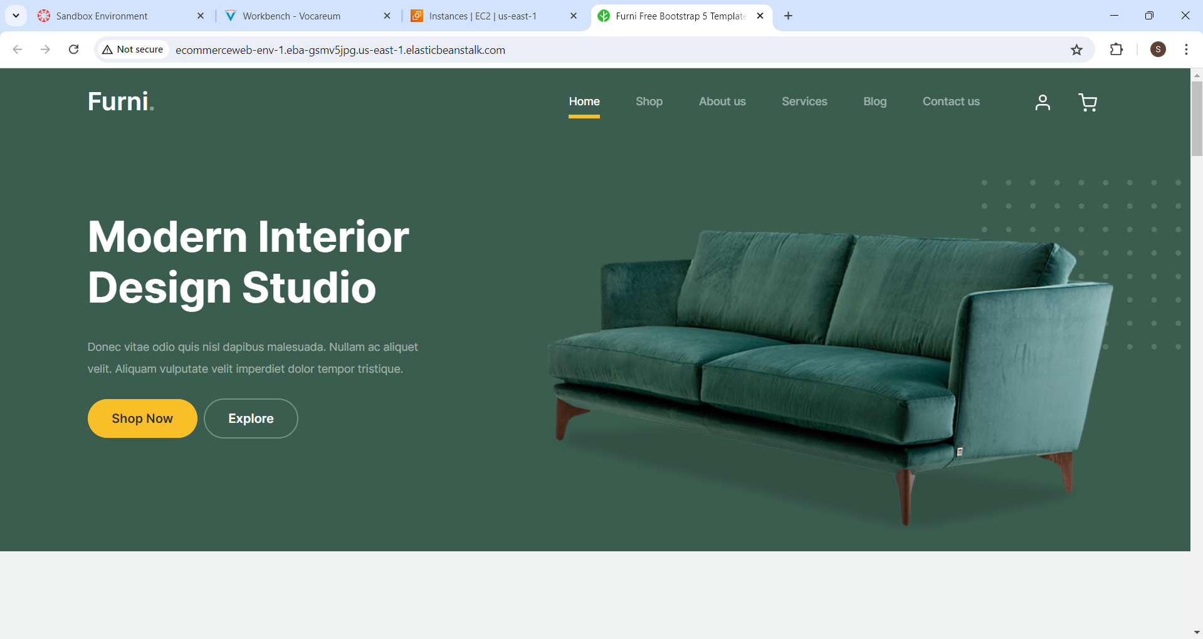

**Figure 8.15 Ecommerce webpage**

**CHAPTER 9**

**DEPLOYING AN ECOMMERCE WEBSITE**

**ON S3 BUCKET**

1. Go to the S3 Dashboard

* **S3 (Simple Storage Service)**: An object storage service that offers scalability, data availability, security, and performance.
* In the AWS Management Console, search for "S3" and select it to go to the S3 Dashboard.

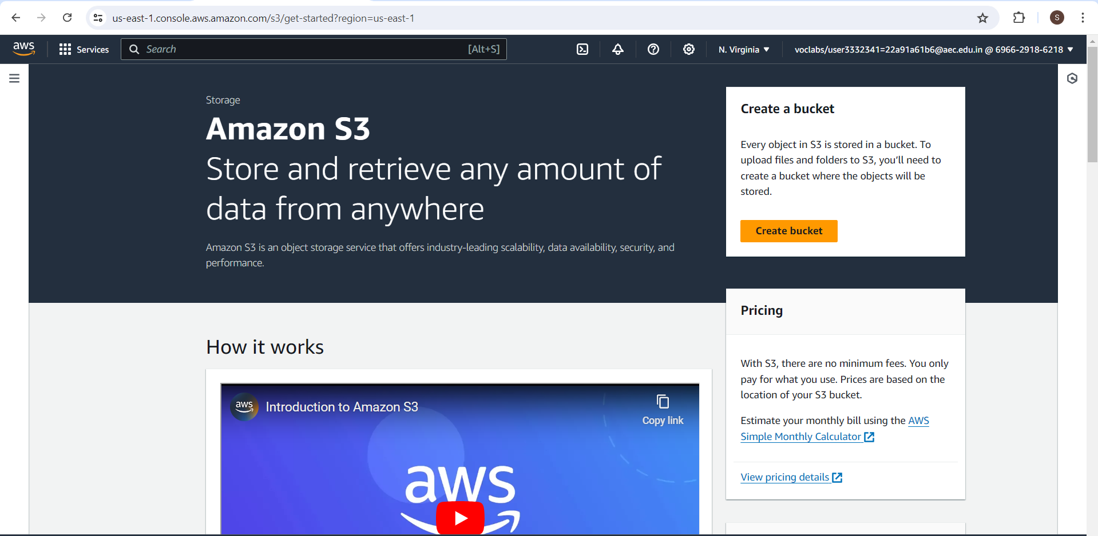

**Figure 9.1 Amazon s3 environment**

2.Create an S3 Bucket

* **S3 Bucket**: A container for storing objects in S3.
* In the S3 Dashboard, click on "Create bucket".
* Specify a unique bucket name (ishipteam2).
* Choose the AWS Region closest to your users.
* Click "Create bucket".

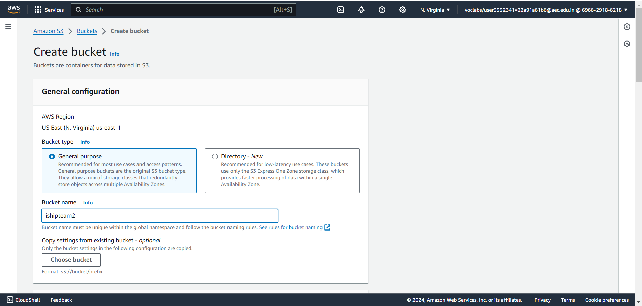

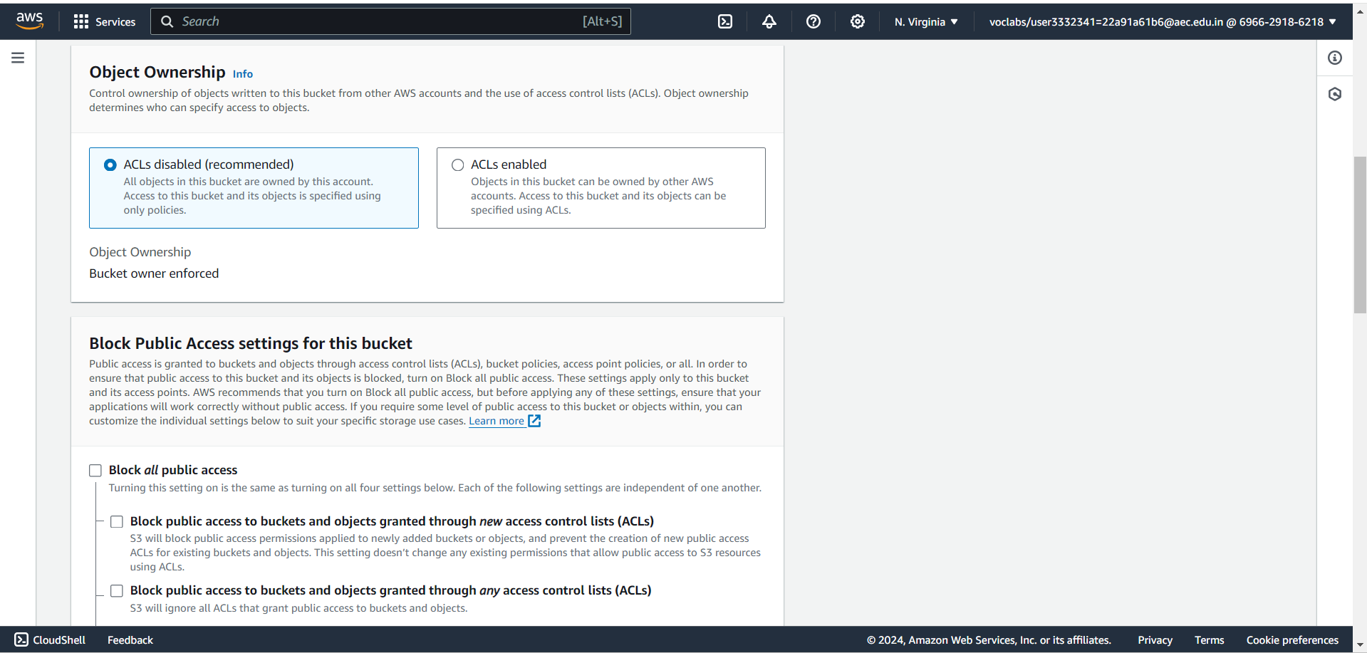

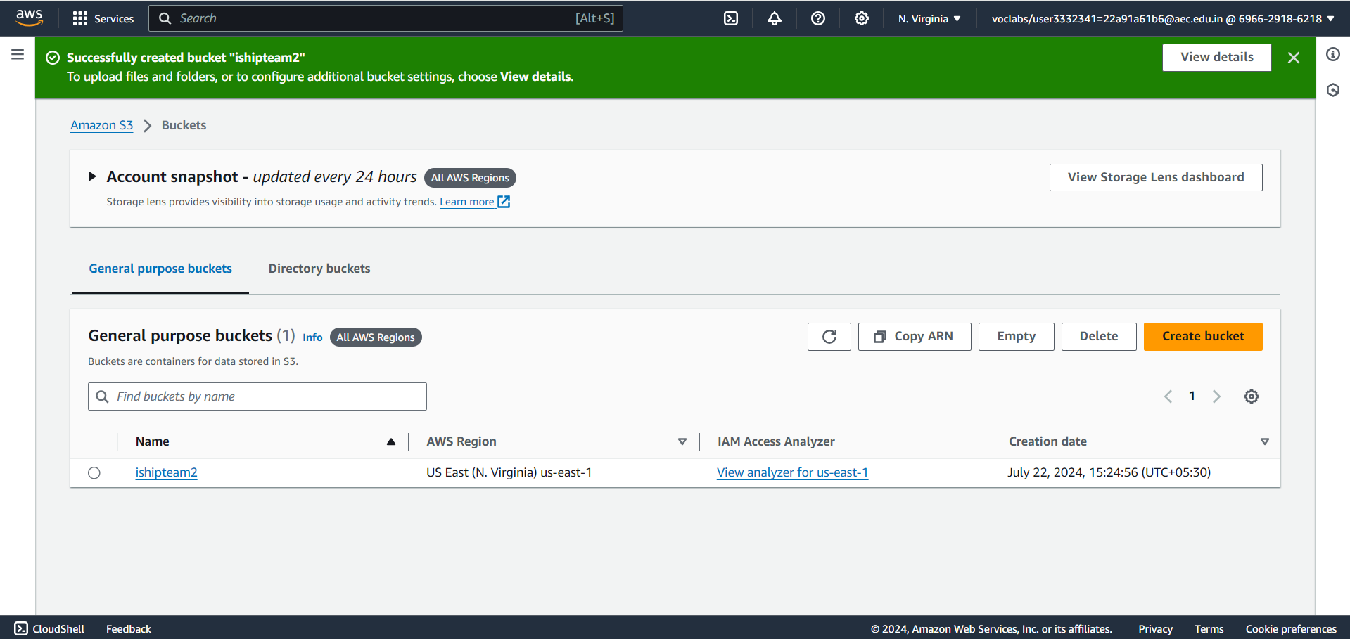

**Figure 9.2 Bucket created successfully**

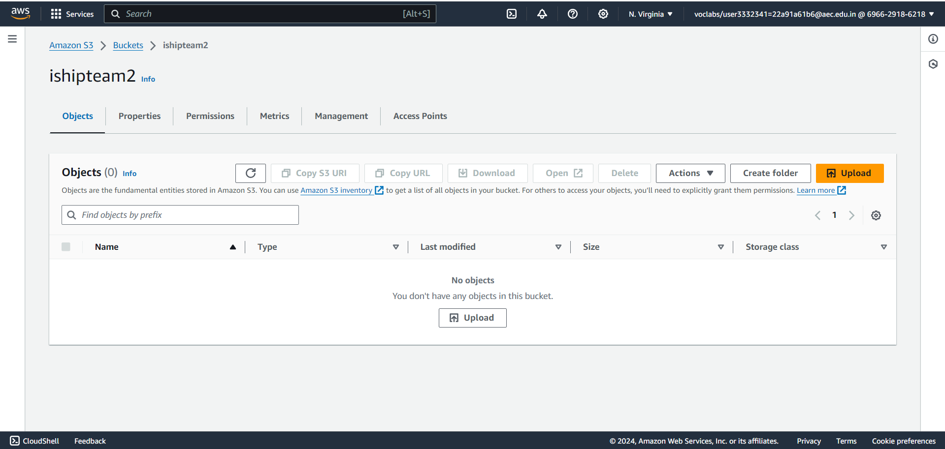

**Figure 9.3 Objects in the Bucket**

3. Set Permissions for Public Access

3.1 Edit Object Ownership

* **Object Ownership**: Determines the ownership of objects uploaded to the bucket, whether by the bucket owner or other AWS accounts.
* Go to the "Permissions" tab of your bucket.
* Scroll down to "Object Ownership" and click "Edit".
* Select "Bucket owner preferred" to ensure the bucket owner has full control over new objects.
* Click "Save changes".

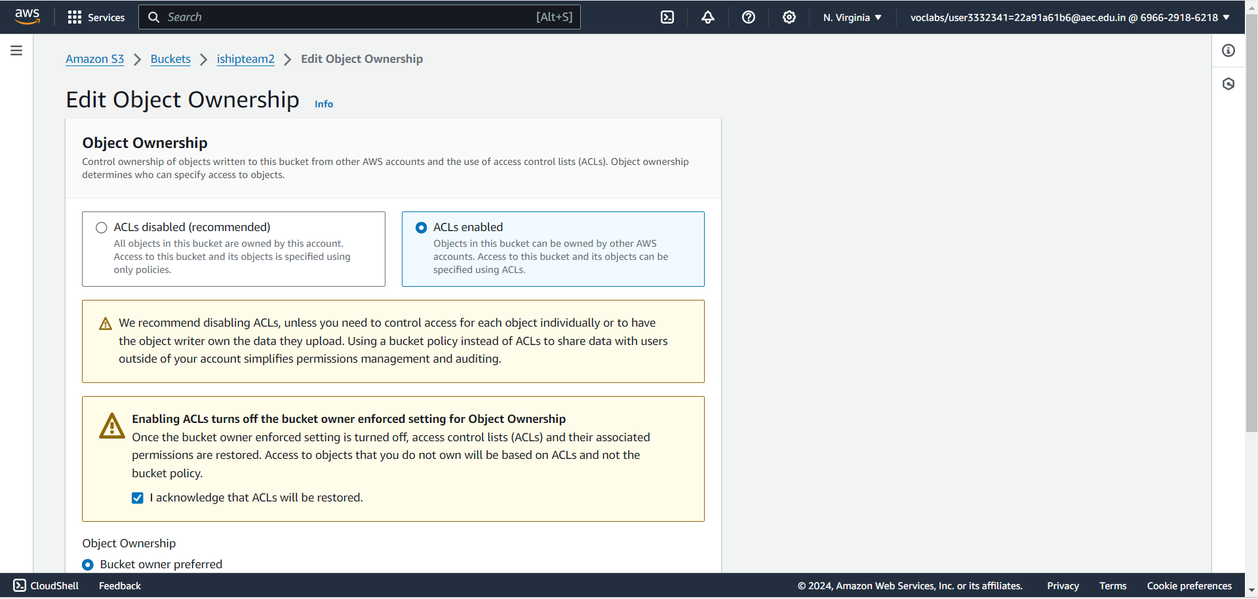

**Figure 9.4** **Edit Object Ownership**

3.2 Edit Access Control List (ACL)

* **Access Control List (ACL)**: Defines which AWS accounts or groups are granted access and the type of access.
* Go to the "Permissions" tab of your bucket.
* Scroll down to "Access control list (ACL)" and click "Edit".
* Under "Access to this bucket", select "Everyone'' and shave changes.

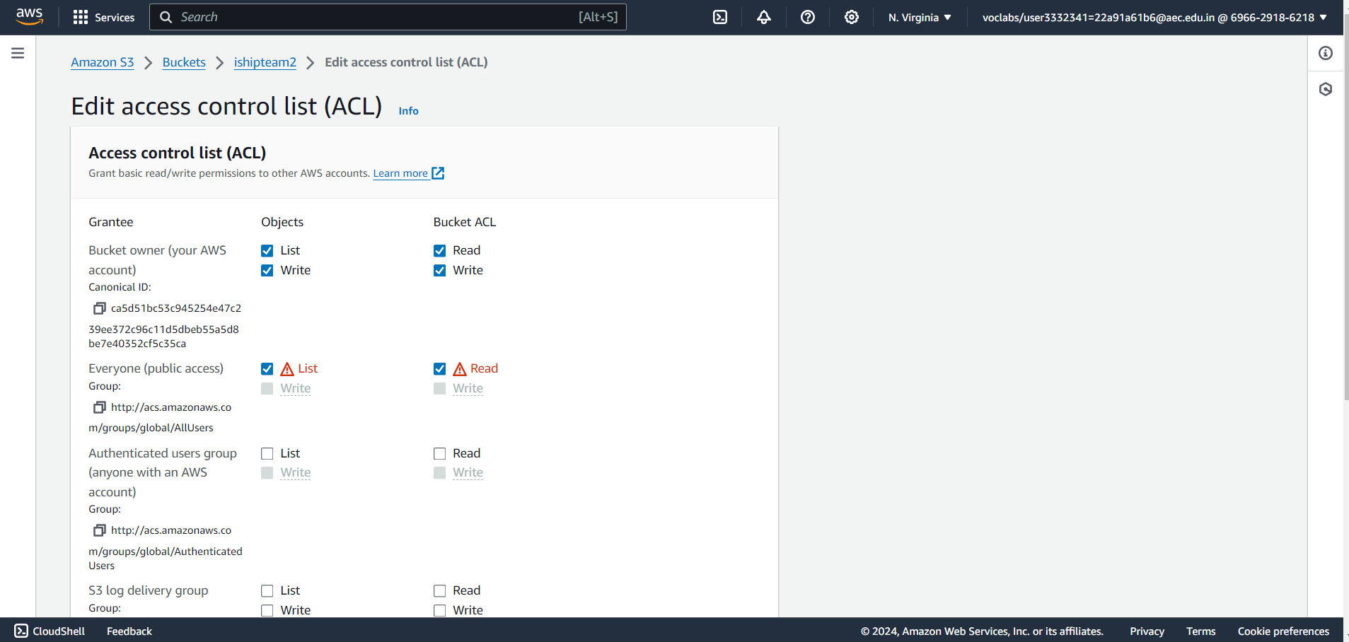

**Figure 9.5 Edit access control list**

4.Upload Your Website Files to the S3 Bucket

* Go to the "Objects" tab in your bucket.
* Click "Upload" and add your website files (HTML, CSS, JS, images, etc.).
* Click "Upload" to transfer the files to your S3 bucket.

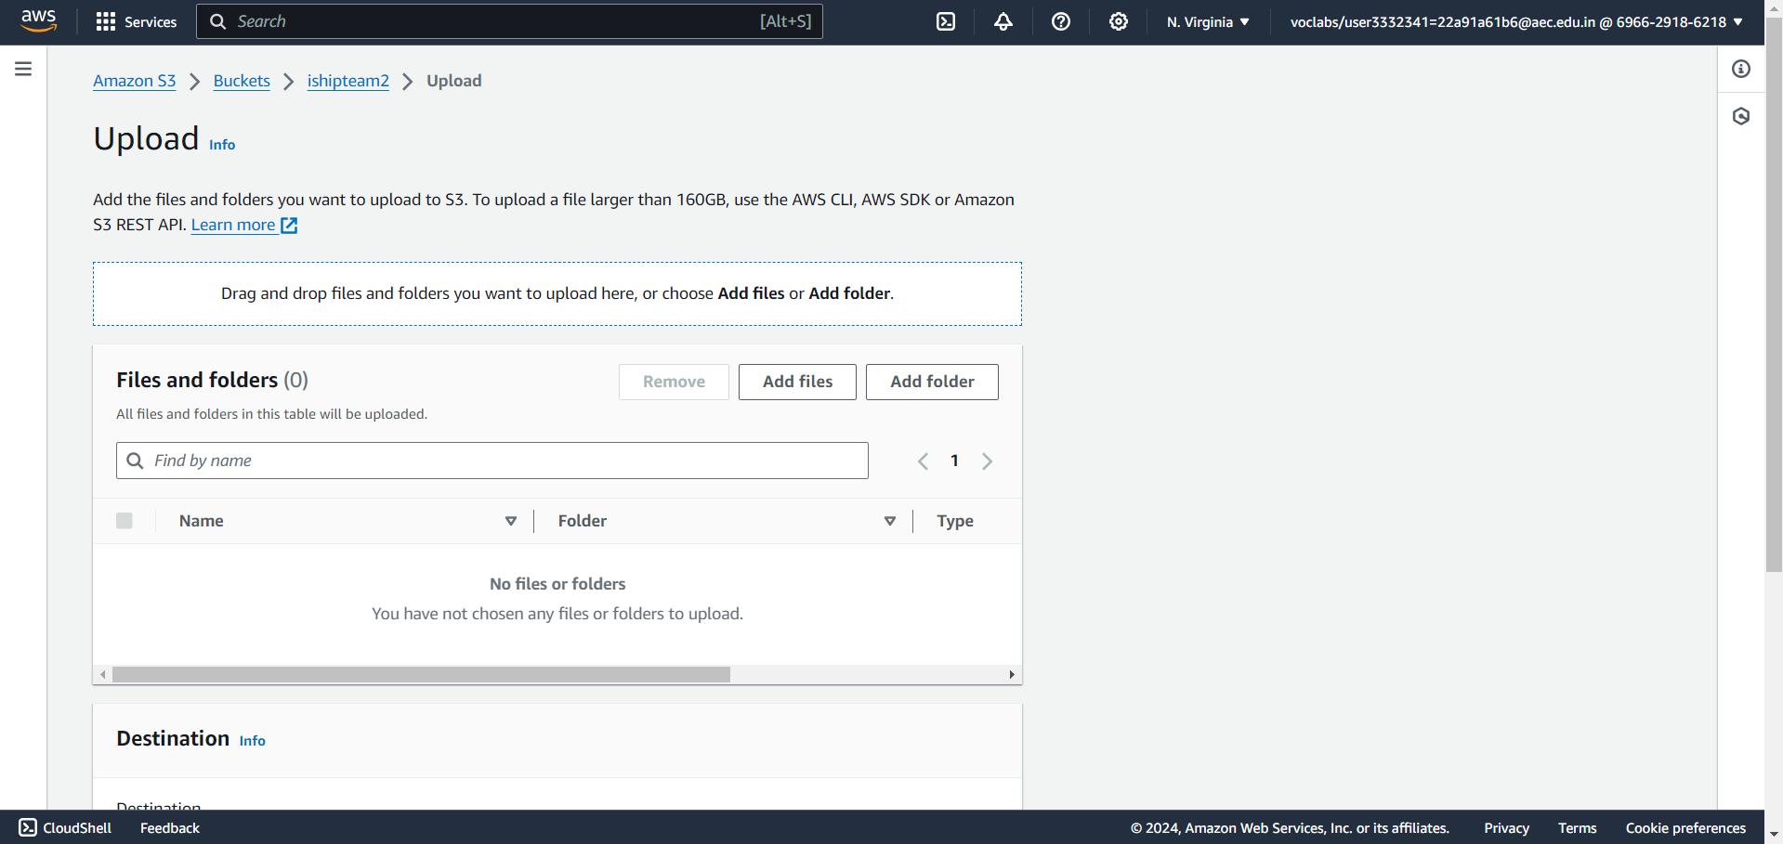

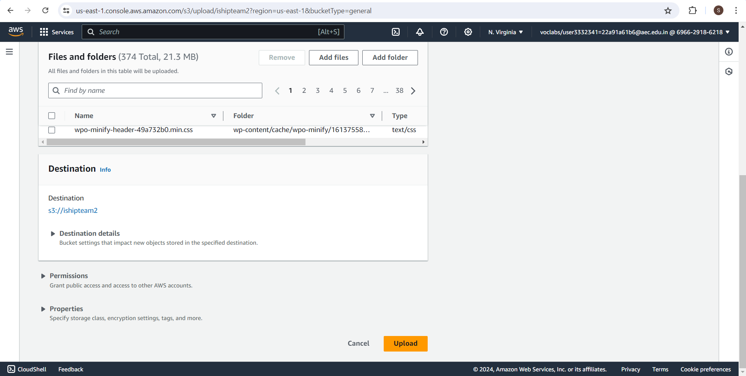

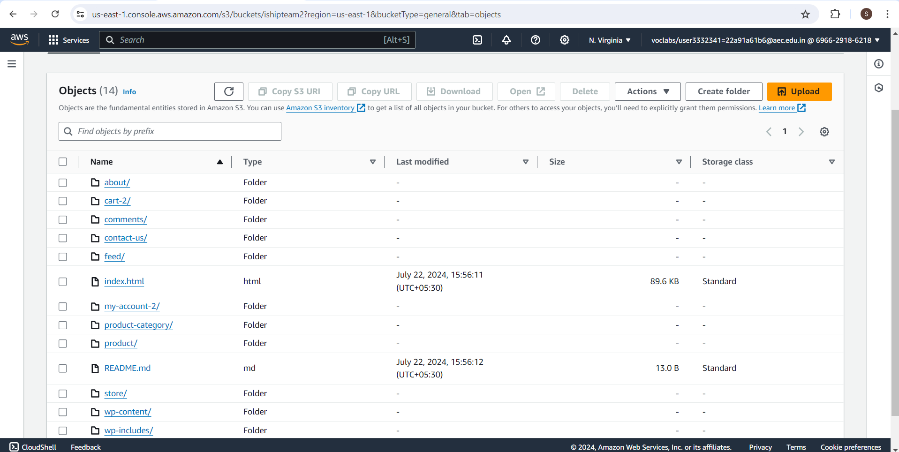

**Figure 9.6 Upload files to Bucket**

5.Set Permissions for Public Access

* Select all the uploaded files.
* Click on "Actions" and choose "Make public".
* Confirm the action.

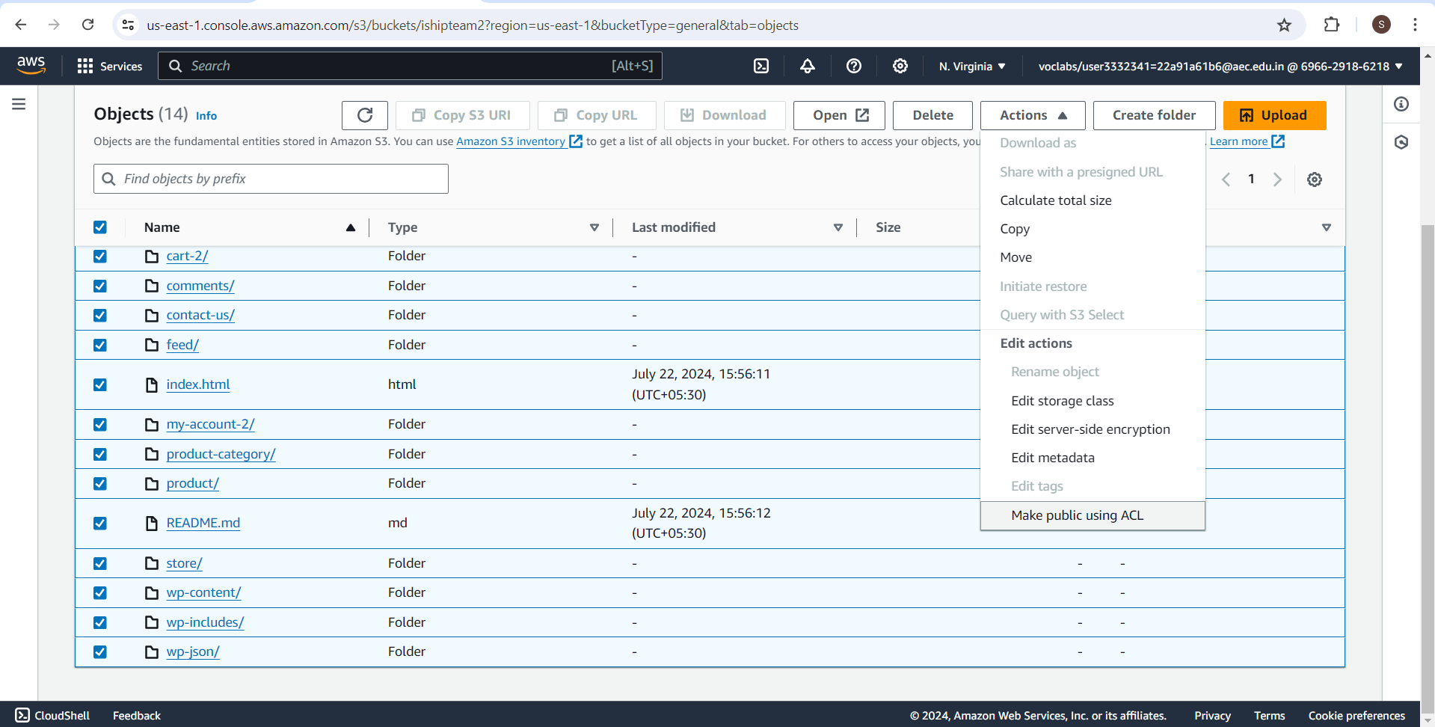

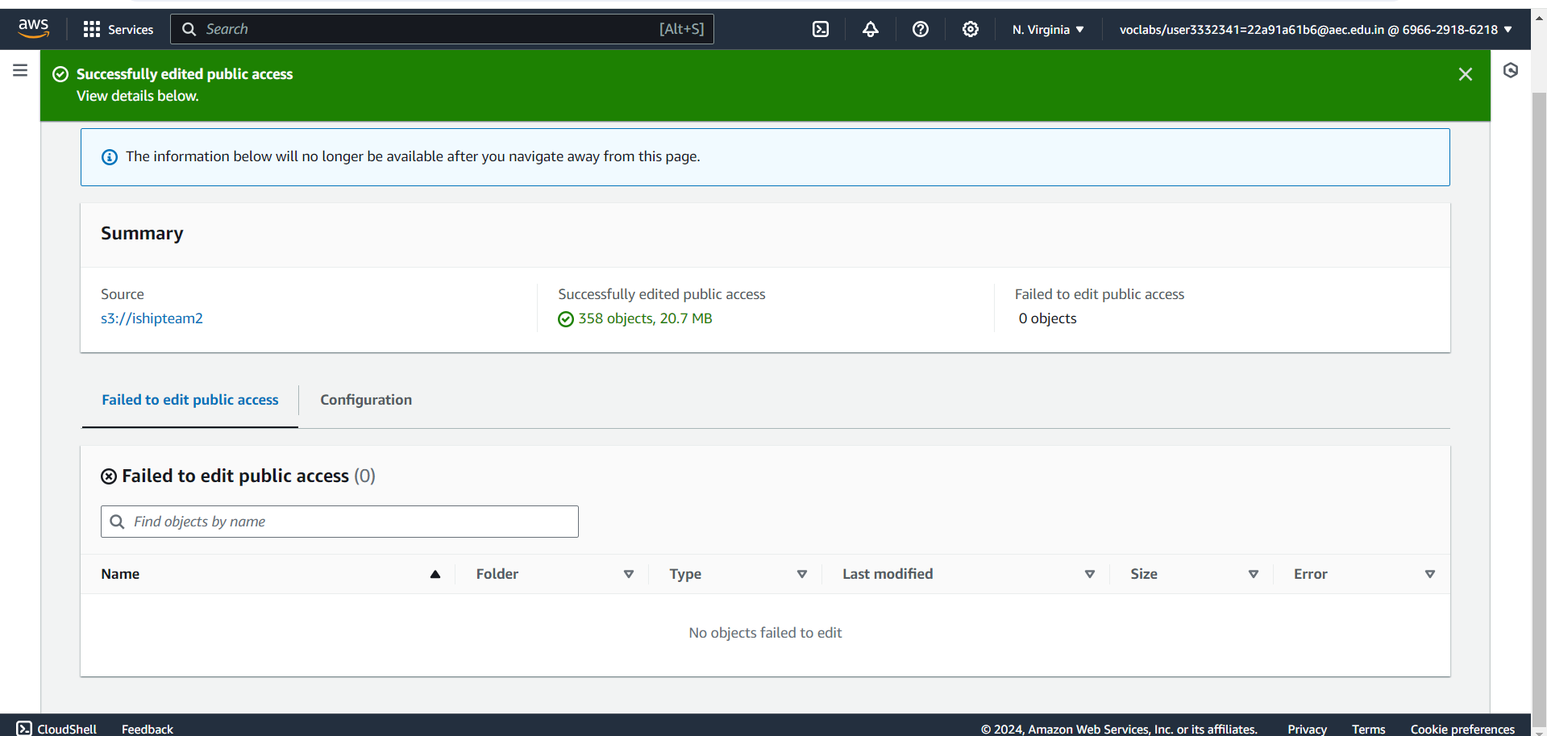

**Figure 9.7 Successfully edited public access**

6.Configure Bucket for Static Website Hosting

* In the bucket's "Properties" tab, scroll down to "Static website hosting" and click "Edit".
* Select "Enable" and specify the index document, click "Save changes".

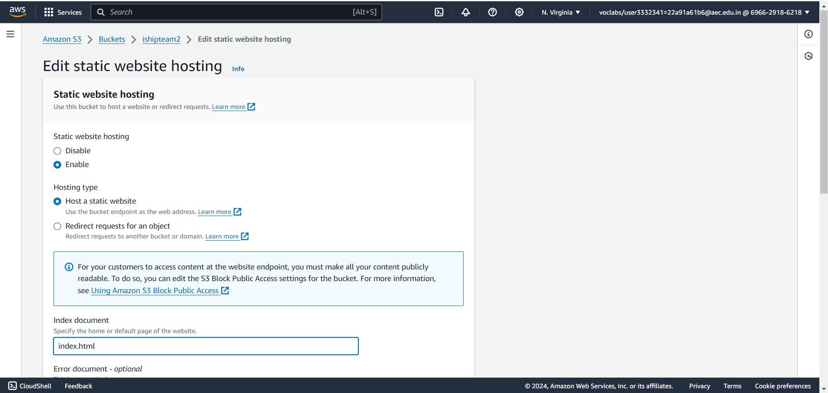

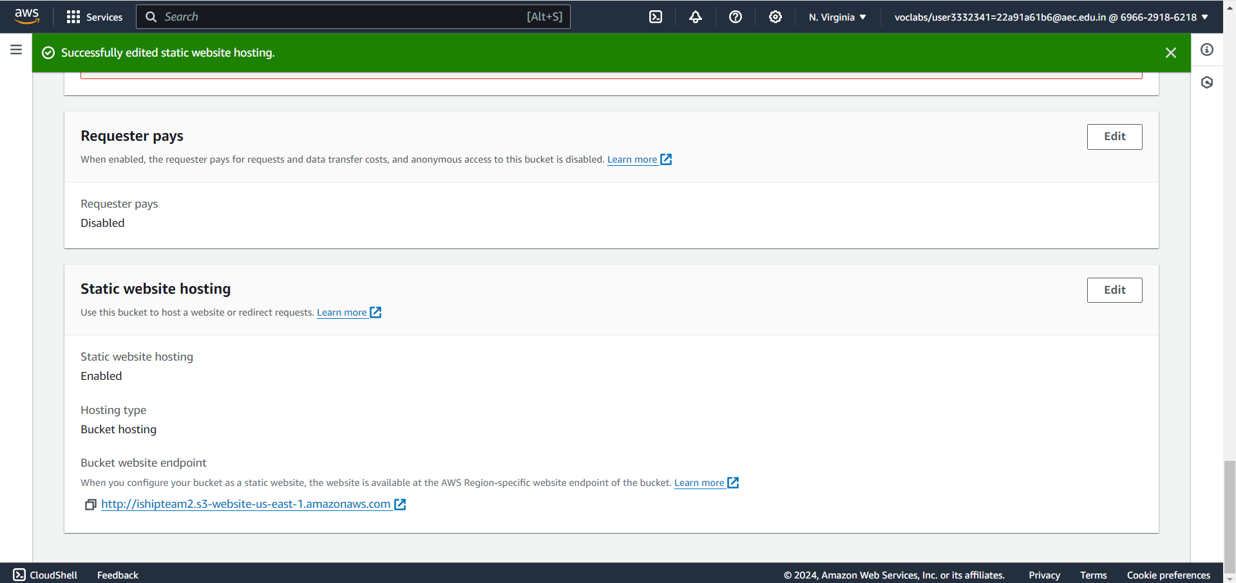

**Figure 9.8 Successfully edited static website hosting**

7.Access Your Website

* Go to the "Properties" tab of your bucket.
* Under "Static website hosting", find the "Bucket website endpoint".
* Copy the endpoint URL, open a web browser and paste the URL to view your deployed website.

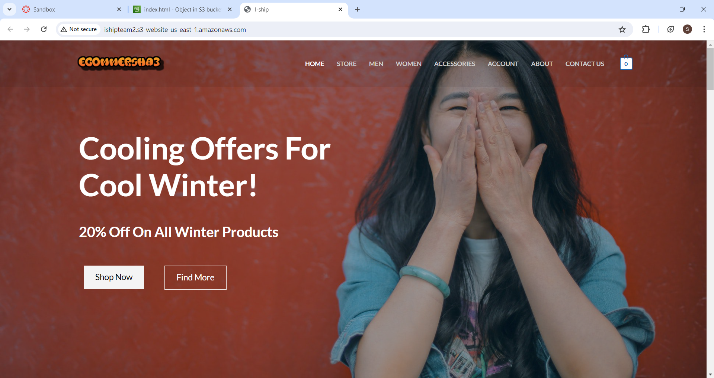

**Figure 9.9 Ecommerce website**

8. Enable Versioning on the S3 Bucket

* **Versioning**: A means of keeping multiple variants of an object in the same bucket.
* Select the bucket you created.
* Go to the "Properties" tab.
* Scroll down to "Bucket Versioning" and click "Edit".
* Select "Enable" and click "Save changes".

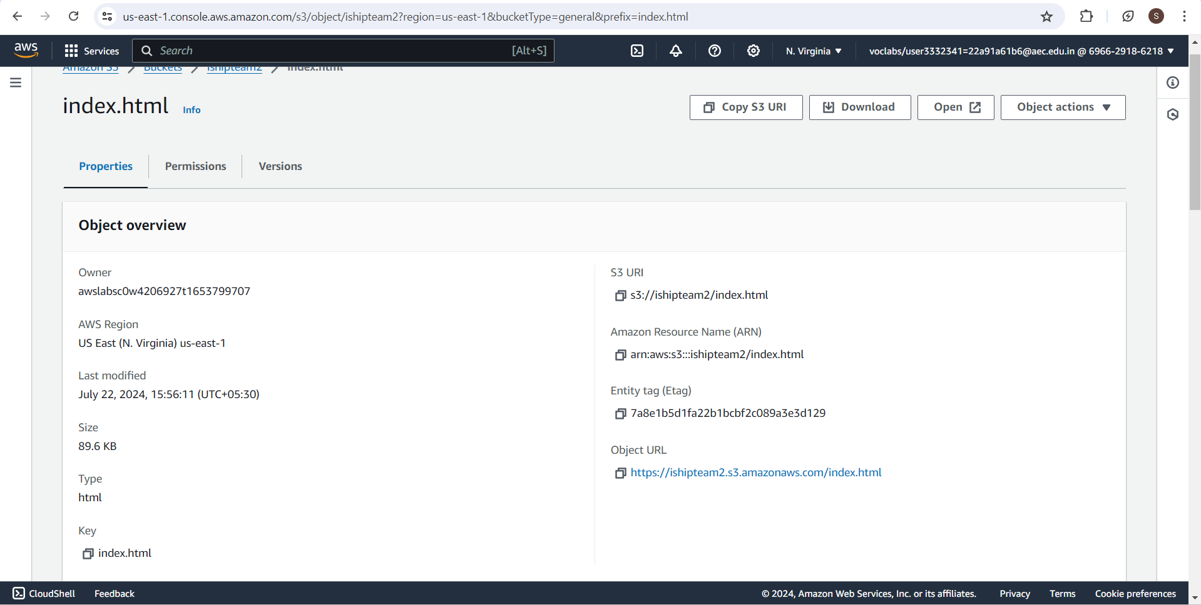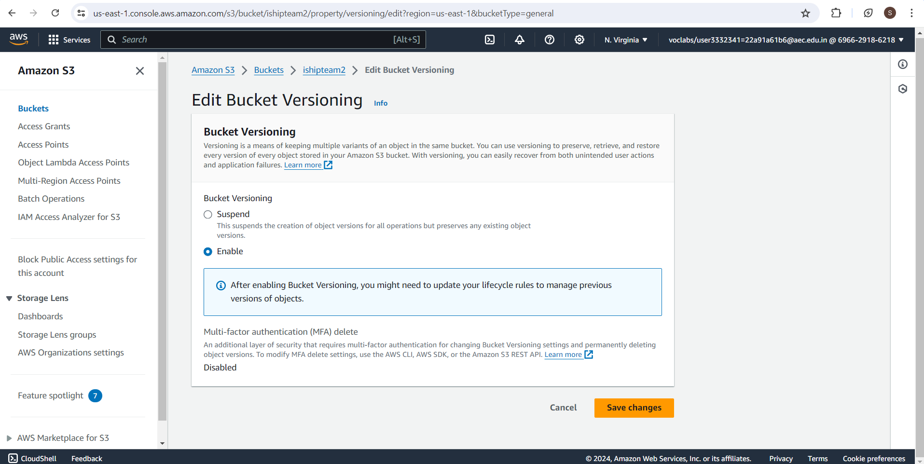

**Figure 9.10 Enabled Bucket Versioning**

9.Edit the browser and upload the files.

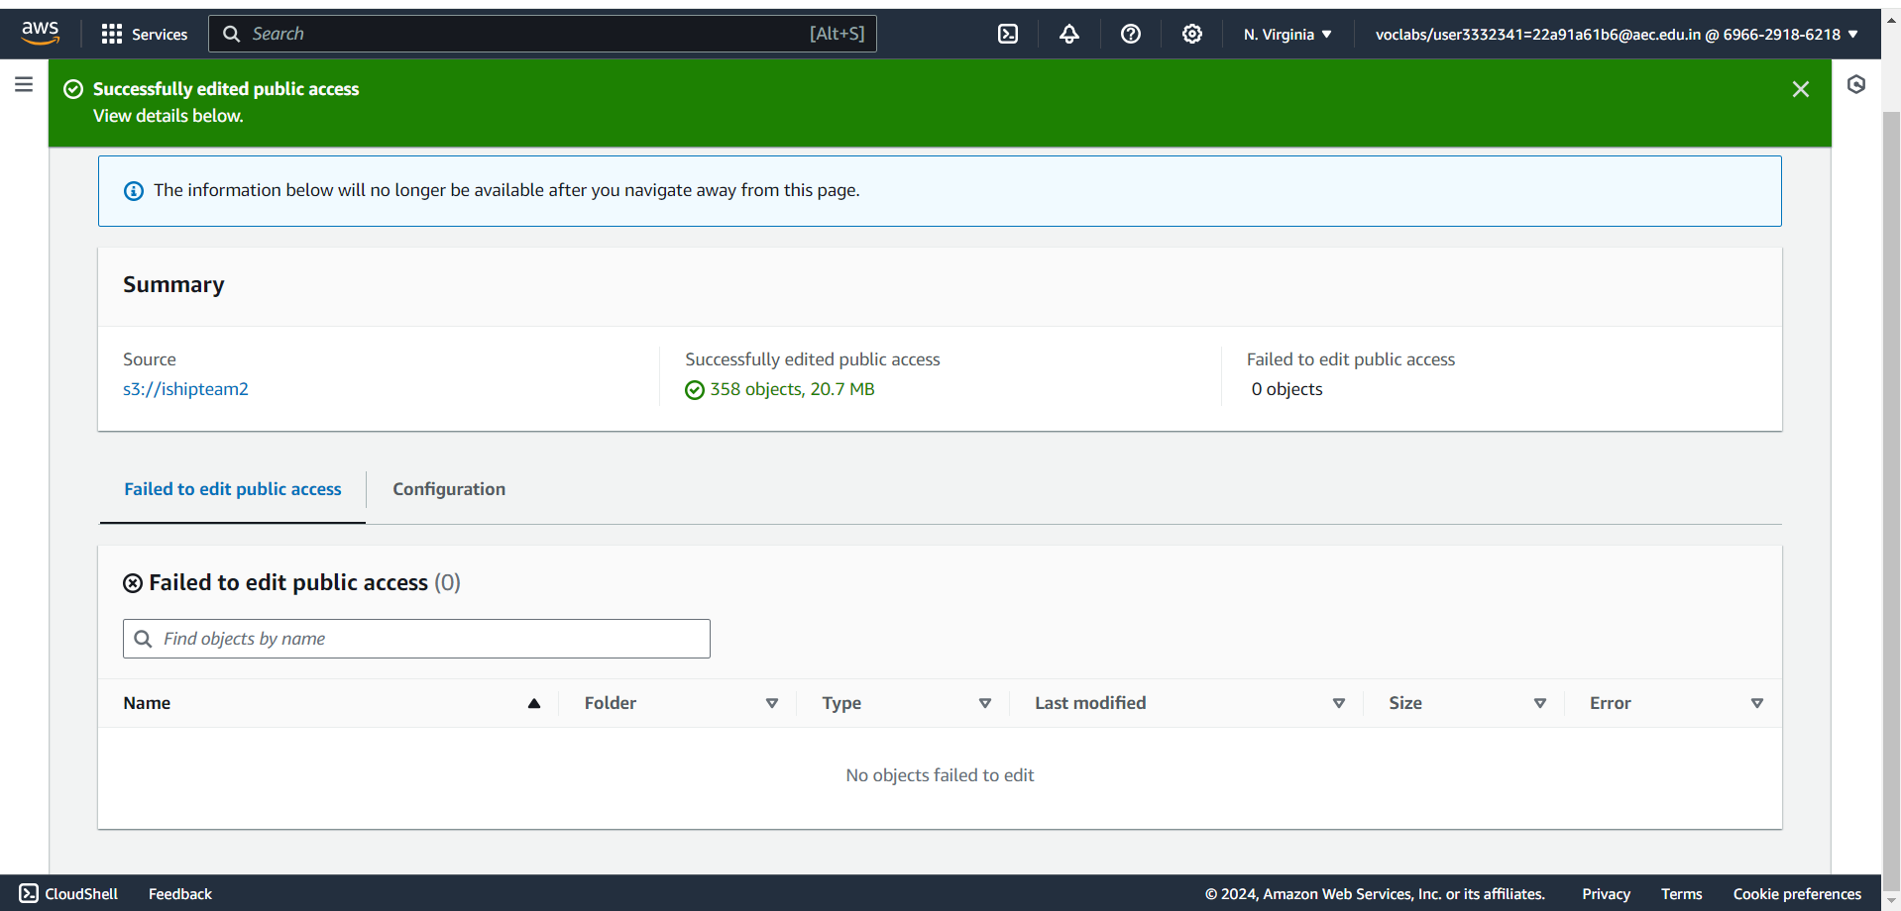

**Figure 9.11 Updated files and uploaded**

10.Browse the public IP address.

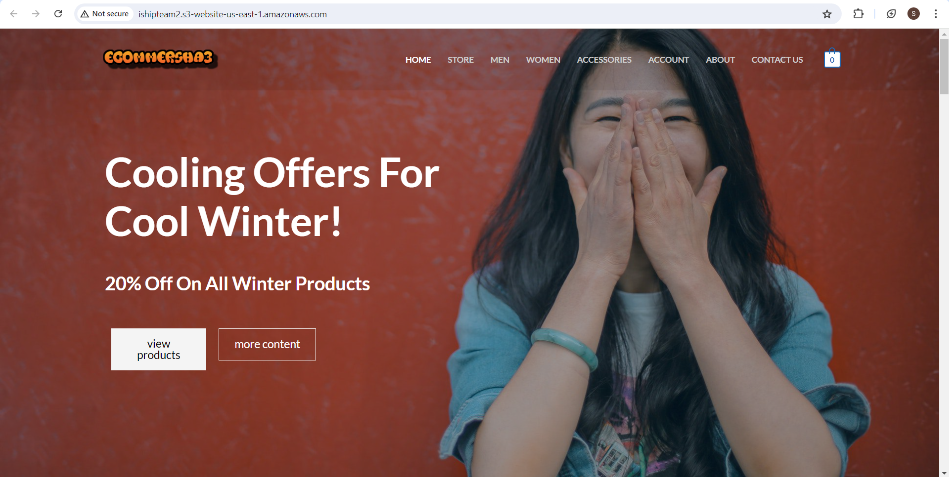

**Figure 9.12 Updated Ecommerce website**

11. Show Versioning and Manage Versions

* **Show Versioning**: Displaying the versions of objects to manage and revert to previous versions if needed.
* Go to the "Objects" tab of your bucket.
* Click on the "List versions" button to enable the display of object versions.
* You will see multiple versions of your objects, each with a unique version ID.

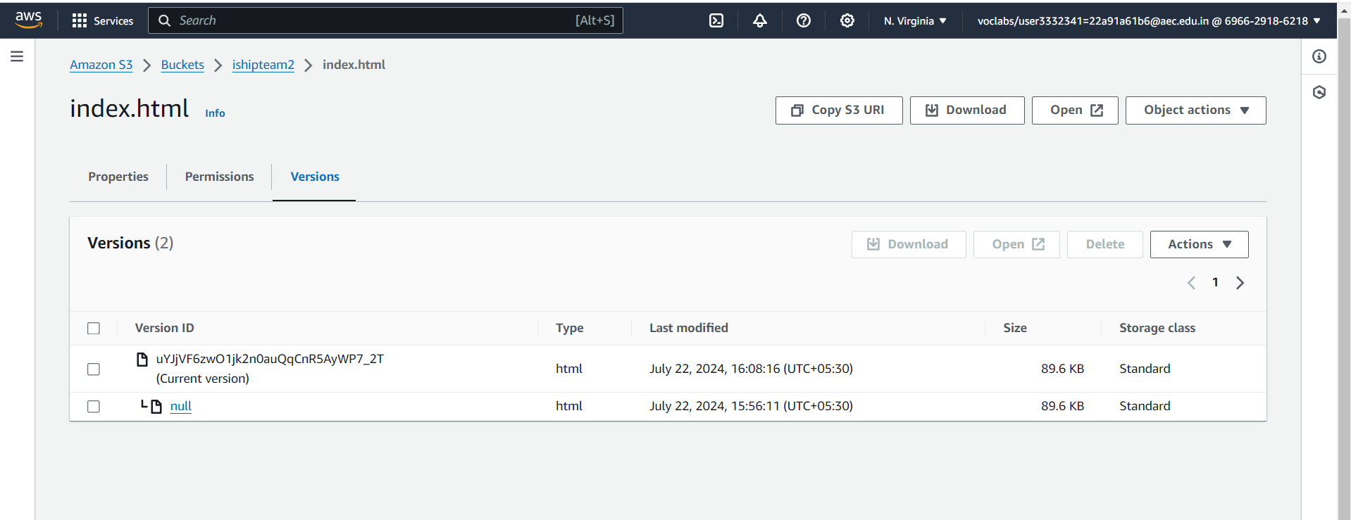

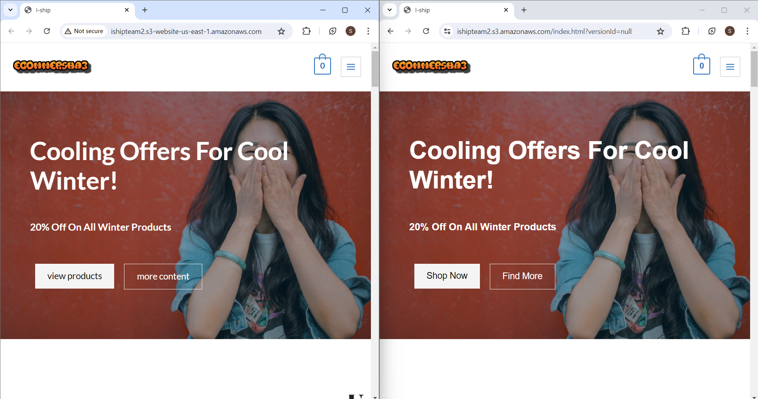

**Figure 9.13 Versions of the website available**

**CHAPTER 10**

**TECHNICAL RESOURCES**

Basically, we will use AWS Academy and MobaXterm to deploy an eCommerce website on EC2 instances running both Ubuntu and Windows AMIs, as well as utilizing AWS Elastic Beanstalk and AWS S3 with versioning enabled. AWS Academy provides comprehensive learning resources and hands-on labs to help you understand AWS services, while MobaXterm is a powerful remote desktop software for managing your remote sessions.

**AWS Academy**

AWS Academy Offers educational resources and hands-on labs to teach AWS services and cloud computing concepts.

**Access AWS Academy**:

* Sign up for AWS Academy:-
* Enroll through your institution or organization's learning portal.
* Gain access to a variety of courses and hands-on labs focused on AWS services.
* Setup AWS Account:-
* Follow the step-by-step instructions provided by AWS Academy to create your AWS account.
* Utilize the credits provided by AWS Academy to explore and practice deploying applications on AWS.

**MobaXterm**

MobaXterm is a remote desktop software that allows you to manage your remote sessions and perform various tasks on remote servers.

**Install MobaXterm**:

* Download and Install:-
* Visit the official MobaXterm Download page.
* Download the appropriate version for your operating system and follow the installation instructions.
* Connect to AWS EC2 Instance:-
* Launch MobaXterm:

1. Open MobaXterm on your computer.

* Create a New Session:

1. Click on the "Session" button to start a new session.
2. Choose "SSH" as the session type to initiate a secure shell connection.

* Enter Connection Details:

1. Input the public IP address of your EC2 instance.
2. Provide the path to your key pair file to establish a secure connection.
3. Click "OK" to connect to your EC2 instance securely.

**Deploying an eCommerce Website on AWS**

**EC2 (Elastic Compute Cloud)** is a web service that provides resizable compute capacity in the cloud.

* **Launch an EC2 Instance with Ubuntu AMI**:
* Go to the EC2 Dashboard and click “Launch Instance”.
* Choose an Ubuntu Server AMI (e.g., Ubuntu 22.04 LTS).
* Select an instance type (e.g., t2.micro, which is eligible for the free tier).
* Download the key pair to securely connect to your instance.
* Edit the network settings:
  1. Select the VPC and subnet.
  2. Enable auto-assigned public IP.
* Configure instance details, add storage, and configure security groups (allow HTTP, HTTPS, and SSH).
* Review and launch the instance.
* **Launch an EC2 Instance with Windows AMI**:
* Go to the EC2 Dashboard and click “Launch Instance”.
* Choose a Windows Server AMI (e.g., Windows Server 2019 Base).
* Select an instance type.
* Download the key pair to securely connect to your instance.
* Edit the network settings:
  1. Select the VPC and subnet.
  2. Enable auto-assigned public IP.
* Configure instance details, add storage, and configure security groups (allow RDP).
* Review and launch the instance.
* **Connect to Ubuntu EC2 Instance Using MobaXterm**:
* Open MobaXterm.
* Create a new SSH session.
* Enter the public IP address of your Ubuntu instance.
* Specify the key pair file.
* Connect and log in.
* **Connect to Windows EC2 Instance Using MobaXterm**:
* Open MobaXterm.
* Create a new RDP session.
* Enter the public IP address of your Windows instance.
* Specify the key pair file and extracted password.
* Connect and log in.

Utilizing cloud services like AWS, you can deploy and manage your eCommerce website efficiently. AWS provides a variety of tools and services such as S3 for storage, Elastic Beanstalk for application deployment, and EC2 for compute resources. MobaXterm aids in managing these resources remotely, providing a robust environment for your cloud operations.

**CHAPTER 11**

**CHALLENGES FACED**

* **Configuration Issues:**
* **EC2:** Misconfigurations in security groups, IAM roles, or instance types can lead to connectivity issues or security vulnerabilities.
* **Elastic Beanstalk:** Configuration errors in deployment packages or environment settings can cause deployment failures.
* **S3 Versioning:** Misunderstanding versioning can lead to unexpected storage costs and management complexity.
* **Security Management:**
* Ensuring the proper setup of security groups, IAM policies, and key management to protect data and resources.
* **Cost Management:**
* Monitoring and optimizing costs to avoid unexpected expenses due to over-provisioning or unused resources.
* **Scalability Challenges:**
* Designing the architecture to handle varying traffic loads without compromising performance.
* **Integration Complexities:**
* Integrating various AWS services (EC2, S3, RDS, etc.) smoothly to ensure seamless operation.
* **Data Migration:**
* Moving existing data to AWS and ensuring data integrity during the transfer.
* **Learning Curve:**
* Familiarizing with AWS services, tools, and best practices, especially for team members new to AWS.
* **Application Dependencies:**
* Managing dependencies and ensuring compatibility between various software components and AWS services.

**CHAPTER 12**

**CONCLUSION**

Completing an internship at Technical Hub in the field of cloud technology has been a valuable and enriching experience. Over the course of my internship, I have gained a deep understanding of EC2 practices, improved my technical skills, and developed a range of soft skills that are essential for a successful career in this field.

One of the most significant takeaways from my internship at Technical Hub has been the hands-on experience I gained in working with various cloud development technologies and tools. I had the opportunity to work on real projects, from conceptualization to deployment, which allowed me to apply the knowledge I had gained from my coursework in a practical setting. This experience helped me become proficient in the concepts.

Furthermore, the collaborative environment at Technical Hub encouraged me to enhance my teamwork and communication skills. I learned how to effectively communicate with team members, gather requirements, and provide regular updates on project progress. This collaborative approach not only improved the quality of the projects but also fostered a sense of camaraderie within the team.

Another vital aspect of my internship at Technical Hub was the exposure to industry best practices and the importance of adhering to enhancing security and design principles. This experience has instilled in me a commitment to ensuring the security and performance of web applications.

Additionally, I had the opportunity to work on projects with real clients, which provided me with insights into the client's perspective and the importance of meeting their expectations and deadlines. This exposure to client interactions has been invaluable in developing my client-facing skills.

In conclusion, my cloud technology internship at Technical Hub has been a transformative experience that has equipped me with the knowledge, skills, and confidence to pursue a career in cloud development. I am grateful for the guidance and mentorship I received during my internship, and I look forward to applying what I have learned to future projects and endeavours in the field of cloud development. I am excited about the prospect of continuing to grow as a cloud developer and contributing to the ever-evolving world of technology.

**References:**

* AWS Certified Solutions Architect Official Study Guide: Associate Exam by Ben Piper & David Clinton.
* AWS Certified SysOps Administrator – Associate Guide by Marko Sluga.
* AWS Certified Advanced Networking – Specialty Exam Guide by Marko Sluga.